

National College of Ireland

Project Submission Sheet

Student Name: | Eoin Fitzsimons
Student ID: | X23151374
Programme: | Computing | Year: | 4
Module: | Final Project
Lecturer: | Frances Sheridan
Submission Due Date: | 03/08/2026
Project Title: | Momentum
Word Count:

Academic Integrity Certificate Verification Code: i1hvGctrkB

I hereby certify that the information contained in this (my submission) is information pertaining to research I conducted for this project. All information other than my own contribution will be fully referenced and listed in the relevant bibliography section at the rear of the project.
ALL internet material must be referenced in the references section. Students are encouraged to use the Harvard Referencing Standard or appropriate referencing style supplied by the Library. To use other author's written or electronic work is illegal (plagiarism) and may result in disciplinary action. Students may be required to undergo a viva (oral examination) if there is suspicion about the validity of their submitted work.

Note: Academic Integrity Course Requirement – Starting Monday, 19th January 2026, all students are required to successfully complete the Epigeum Academic Integrity Course, which is available on Moodle. This is a self-paced online course consisting of 4 modules and will take approximately 2 hours to complete. Once you have successfully completed the course, you will receive a Certificate & Verification Code. This code must be included on the Project Cover Sheet when submitting your work. For full details and guidance, please visit: 🔗 ttps://libguides.ncirl.ie/academicintegrity/epigeumforstudents

Signature: | Eoin Fitzsimons
Date: | 03/08/2026

PLEASE READ THE FOLLOWING INSTRUCTIONS:

1. Please attach a completed copy of this sheet to each project (including multiple copies).
2. Projects should be submitted to your Programme Coordinator.
3. You must ensure that you retain a HARD COPY of ALL projects, both for your own reference and in case a project is lost or mislaid. It is not sufficient to keep a copy on computer. Please do not bind projects or place in covers unless specifically requested.
4. You must ensure that all projects are submitted to your Programme Coordinator on or before the required submission date. Late submissions will incur penalties.
5. All projects must be submitted and passed in order to successfully complete the year. Any project/assignment not submitted will be marked as a fail.
6. Please check that you read AI and Academic Integrity Acknowledgement Supplments in this document

Office Use Only
Signature:
Date:
Penalty Applied (if applicable):

AI Acknowledgement Supplement
[Insert Module Name]
[Insert Title of your assignment]

Your Name/Student Number | Course | Date

This section is a supplement to the main assignment, to be used if AI was used in any capacity in the creation of your assignment; if you have queries about how to do this, please contact your lecturer. For an example of how to fill these sections out, please click here.
AI Acknowledgment
This section acknowledges the AI tools that were utilized in the process of completing this assignment.
Tool Name | Brief Description | Link to tool

Description of AI Usage
This section provides a more detailed description of how the AI tools were used in the assignment. It includes information about the prompts given to the AI tool, the responses received, and how these responses were utilized or modified in the assignment. One table should be used for each tool used.
[Insert Tool Name]
[Insert Description of use]
[Insert Sample prompt] | [Insert Sample response]

Evidence of AI Usage
This section includes evidence of significant prompts and responses used or generated through the AI tool. It should provide a clear understanding of the extent to which the AI tool was used in the assignment. Evidence may be attached via screenshots or text.
Additional Evidence:
[Place evidence here]



National College of Ireland
Computing
Software Development
2025/2026
Eoin Fitzsimons
X23151374
X23151374@student.ncirl.ie

Momentum
Technical Report

Contents
Executive Summary 7
1 Introduction 8
1.1 Background 8
1.2 Aims 8
1.3 Technology 8
1.4 Structure 10
2 System 11
2.1 Requirements 11
2.1.1 Functional Requirements 11
2.1.2 Data Requirements 24
2.1.3 User Requirements 24
2.1.4 Environmental Requirements 25
2.1.5 Usability Requirements 26
2.2 Design & Architecture 27
2.2.1 System Architecture Overview 27
2.2.2 Container Diagram 27
2.2.3 Component Diagram 28
2.2.4 Runtime Data 29
2.2.5 Data Flow 30
2.3 Implementation 31
2.3.1 Telemetry 31
2.3.2 Driver Creation 34
2.3.3 Track 37
2.4 Graphical User Interface (GUI) 42
2.4.1 Main Menu 42
2.4.2 Accessibility 43
2.4.3 Accessibility in action 44
2.4.4 Racetrack 45
2.4.5 Telemetry 45
2.4.6 Standings 46
2.5 Testing 47
2.5.1 Tools 47
2.5.2 Unit 49
2.5.3 Class 51
2.5.4 Integration 52
2.5.5 System 54
2.6 Evaluation 58
2.6.1 Functional Evaluation 58
2.6.2 Correctness and Reliability Evaluation 58
2.6.3 Performance Evaluation 59
2.6.4 Usability Evaluation 60
2.6.5 Maintainability Evaluation 60
2.6.6 Scalability Evaluation 61
2.6.7 Overall Evaluation 61
3 Conclusions 63
4 Further Development or Research 64
5 References 66
6 Appendices 69
6.1 Project Proposal 69
6.1.1 Objectives 69
Background 70
6.1.2 State of the Art 72
6.1.3 Technical Approach 73
6.1.4 Technical Details 74
6.1.5 Special Resources Required 75
6.1.6 Project Plan 77
6.1.7 Testing 79
6.2 Reflective Journals 80
6.3 Other materials used 83

Executive Summary
Motorsport simulation combines complex systems involving driver characteristics, vehicle performance, and race progression. Momentum is a desktop-based motorsport simulation prototype developed to explore how an agent-based simulation engine can be combined with a graphical interface to present race behaviour in an understandable format. Unlike traditional racing games that focus on direct vehicle control, Momentum focuses on observing and analysing a complete simulated race.
The primary objective of the project was to design and implement an application capable of generating autonomous driver agents, simulating race progression, displaying live telemetry, and presenting final race results. The system was developed using Python and PyQt6, with a modular architecture separating the graphical interface, simulation logic, and configuration data. Drivers are generated using predefined racing archetypes and performance attributes, allowing variation between competitors and producing different race outcomes. A telemetry system records race information such as driver position, lap progress, time gaps, and vehicle state, allowing users to monitor the simulation as it occurs.
The completed system successfully implements the core requirements of the minimum viable product, including race simulation, live visualisation, driver information display, accessibility options, and results generation. Automated testing using pytest and pytest-qt was used to verify individual components and interactions between system layers, with all implemented tests passing.
The project demonstrates the application of software engineering principles including object-oriented design, modular architecture, automated testing, and separation of concerns. However, the system is intentionally limited in scope. It does not currently implement advanced motorsport mechanics such as detailed vehicle physics, tyre degradation, fuel strategy, championship progression, or persistent historical data storage.
The final implementation provides a functional foundation for a more advanced motorsport simulation platform. Future development could expand the simulation through improved vehicle modelling, intelligent driver decision-making, additional race mechanics, improved visual and audio assets, and database-backed progression systems.

Introduction

Background
Motorsport has a long history of combining engineering, strategy, and human decision-making to produce complex competitive environments. Although several motorsport management games exist, many place significant emphasis on graphical presentation and controlling a single team rather than helping users understand how an entire race develops. As a result, it can be difficult for users to observe the factors that influence race outcomes, such as driver behaviour, vehicle condition, or changing race positions.
Momentum was developed to address this by focusing on race simulation rather than graphical realism. The project presents a complete overview of a race, allowing users to observe every driver simultaneously while viewing live telemetry and performance information. Rather than acting as a team manager, the user acts as an observer of the simulation, making it easier to understand how driver characteristics and race events influence the final outcome.
The project also demonstrates software engineering principles including modular architecture, object-oriented design, automated testing, and graphical user interface development. The result is a prototype that combines a simulation engine with an accessible visual interface while remaining within the scope of a final-year undergraduate software development project.

Aims
The primary aim of Momentum is to design and implement a desktop application capable of simulating and visualising a motorsport race in a way that is both understandable and informative.
To achieve this, the project has the following objectives:
- simulate race progression using an agent-based simulation engine;
- provide a graphical representation of the race as it develops;
- generate and display live telemetry for every driver;
- present driver attributes that influence race behaviour;
- display final race classifications and statistics;
- provide accessibility options to improve usability;
- demonstrate the use of modern software engineering techniques including layered architecture, modular design and automated testing.

Technology
Momentum is developed as a desktop application using Python as the primary programming language. Python was selected because it provides strong support for object-oriented programming, rapid prototyping, data processing and simulation development. It is used to implement the simulation engine, including driver agents, vehicle models, race progression logic and telemetry generation.
PyQt6 is used to develop the graphical user interface. It provides the framework required to create desktop windows, layouts, buttons, tables and custom visual components. Within Momentum, PyQt6 is used to display driver information, accessibility settings, the live race view, telemetry data and final race results. (PYPI, 2026)
JSON is used for persistent configuration storage. Track definitions and accessibility preferences are stored in JSON files because the data is structured, lightweight and does not require the complexity of a database for the current project scope. The simulation data itself is stored using Python objects in runtime memory while the application is running.
The dataclasses module is used to create structured representations of system entities such as drivers, cars and race data. This improves code organisation by allowing related attributes and behaviours to be grouped together. (Python, n.d.)
The pathlib and os libraries are used for file and directory management. They allow the application to locate and load required resources, such as configuration files, independently of the user's operating system environment. (Python, n.d.) (Python, n.d.)
The random library is used within the simulation engine to introduce controlled variation into race outcomes. This allows drivers with similar performance levels to produce different results while maintaining a deterministic structure when required through controlled random generation. (Python, n.d.)
pytest is used as the automated testing framework. It allows individual components of the application to be tested throughout development, including driver generation and race controller functionality. This improves reliability by identifying errors before the complete system is executed. (pytest, 2015)
pytest-qt is used alongside pytest to test PyQt6 components. It provides functionality for interacting with graphical interface elements and verifying that the user interface operates correctly. (pypi, 2025)
Git and GitHub are used for version control and project management. Git tracks changes to the source code, allowing previous versions to be restored and development progress to be monitored. GitHub provides remote storage for the project repository and supports maintaining a history of implementation changes. (Git, n.d.) (GitHub Docs, n.d.)
Visual Studio Code is used as the integrated development environment. It provides code editing features, debugging tools, extension support and project management capabilities that support Python development. (Visual Studio Code, n.d.)
Together, these technologies provide the required functionality to implement the simulation engine, graphical interface, data management and testing framework while maintaining a modular and maintainable software structure.

Structure
This report is structured into five main sections. Section 1 introduces the project by describing the background, aims, technology choices, and overall structure of the report.
Section 2 describes the system implementation. This includes the functional requirements, data requirements, user requirements, environmental requirements, usability requirements, system architecture, implementation details, graphical user interface, testing approach, and evaluation of the completed system.
Section 3 provides the conclusion of the project. It discusses the advantages and disadvantages of the system, the strengths of the implementation, and the limitations identified during development.
Section 4 discusses further development opportunities. This section describes possible improvements and extensions that could be implemented with additional time and resources.
Section 5 contains the references used throughout the report, while Section 6 contains supporting material including the original project proposal, reflective journals, and additional project resources.

System

Requirements

Functional Requirements
Category | Meaning | Interpretation
Must Have (M) | Essential requirements | Without these, the system would fail to meet its primary objectives.
Should Have (S) | Important requirements | These add significant value, but the system can still operate without them if necessary.
Could Have (C) | Desirable requirements | Features that are implemented only if time and resources are available.
Won't Have (W) | Out of scope for this release | Requirements that are excluded from the current version but may be considered in future iterations.

The MoSCoW prioritisation method was used to classify functional requirements according to their importance. Core functionality required for the successful completion of a race simulation was classified as Must Have, features that improve the user experience but are not essential to the simulation were classified as Should Have or Could Have, while functionality outside the scope of the minimum viable product (MVP) was classified as Won't Have. (Agile Business Consortium, 2026). For the purpose of the report structure, anything that would be assigned as Won't Have will be placed in the future development section or omitted entirely.
ID | UC | Requirement | Priority | Description
FR1 | UC-1 | View race results | Must | A race may be predefined, as the project focuses primarily on presenting race data clearly.
FR2 | UC-2 | Simulate race progression | Must | A logic-based race simulation is more important than a detailed graphical representation.
FR3 | UC-3 | View live race | Must | A visual display of a predefined logical race is more important than allowing users to set parameters.
FR4 | UC-4 | Configure race settings | Should | User input is more important than visualising the individual elements used to build a race.
FR5 | UC-5 | View driver information | Should | The ability to predict the race outcome beforehand helps users assess the simulation’s predictability.
FR6 | UC-6 | Configure accessibility settings | Could | The project should be accessible from the outset through simplicity, with optional custom settings for less common accessibility needs.

Requirement 1/UC-1 View Race Results - Must

Use Case Diagram
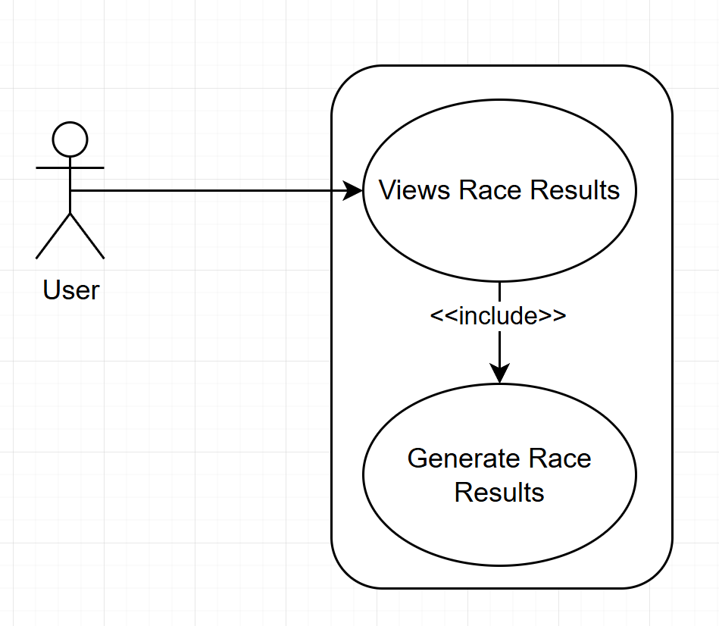

Scope
View the final classification and statistics of a race.

Description & Priority
The system takes events that took place within a race and presents them in a user-friendly manner. This includes determining the final finishing order, displaying driver positions, completed laps, race status, and available performance statistics. The system uses the recorded race state and event history to provide context for the final result, allowing users to understand how the race developed rather than only viewing the final order.
Priority: High

Flow Description

Precondition
- Driver and track data have been loaded.
- The race simulation has been completed successfully.
- Race events and driver states have been recorded.

Activation
This use case begins when the user wishes to see results after the final race lap has been completed.

Main flow
- The system retrieves the final state of all participating drivers from runtime memory.
- The system determines the finishing order based on race completion data.
- The system calculates available race statistics, including finishing times and positions.
- The system processes recorded telemetry data and driver states.
- The system generates the final race classification.
- The system displays the results screen to the user.

Alternate flow
1: Additional statistics unavailable
  - The system detects that optional statistics are unavailable.
  - The system generates the classification using the available race data.
  - The use case continues at step 5 of the main flow.

Exceptional flow
- Race data cannot be processed
  - The system detects missing or corrupted race data.
  - The system displays an error message.
  - The system returns the user to the main menu.

Termination
The system displays the completed race results.

Post condition
The final classification and available race statistics are available for user review.

Requirement 2/UC-2 Simulate race progression - Must

Use Case Diagram
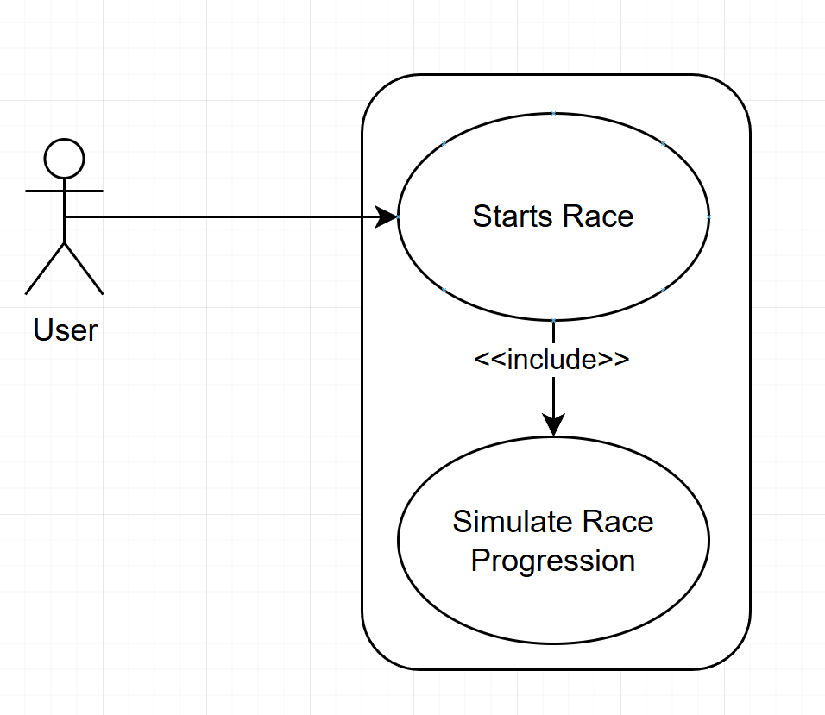

Scope
Execute the race simulation engine from the start of the race until completion.

Description & Priority
The system simulates the progression of a motorsport race by continuously updating driver performance, positions, lap progress, time gaps, and race conditions. The simulation engine calculates race changes based on driver behaviour, vehicle performance, and predefined race factors to produce a simulated race outcome.
The simulation maintains the current race state throughout the event by processing each simulation interval until the required race distance has been completed.
Priority: High

Flow Description

Precondition
- Driver and track data have been loaded.
- Race settings have been configured.
- The simulation engine has been initialised.

Activation
This use case begins when the user starts the race simulation.

Main flow
- The system creates the initial race state using track information from JSON.
- The system assigns starting positions to participating drivers.
- The system begins the simulation process.
- The system calculates driver performance for the current simulation interval.
- The system updates driver positions, lap progress, and time gaps within the simulation.
- The system updates telemetry data and race state information during simulation execution.
- The system repeats the simulation process until the race is completed.

Alternate flow
- A1 – The user ends the race early
  - The system takes the most recent information and records it as if the race finishes
- A2 – The simulation fails due to not all cars finishing
  - The system times out the unfinished cars and marks them as DNF (Did not Finish)

Exceptional flow
- E1 – The simulation fails due to the system crashing
  - The system gives an error message
  - The program resets and goes to the main menu

Termination
The race simulation ends when all required race conditions have been completed.

Post condition
A completed race state exists and is available for generating race results.

Requirement 3/UC-3 View live race - Must

Use Case Diagram
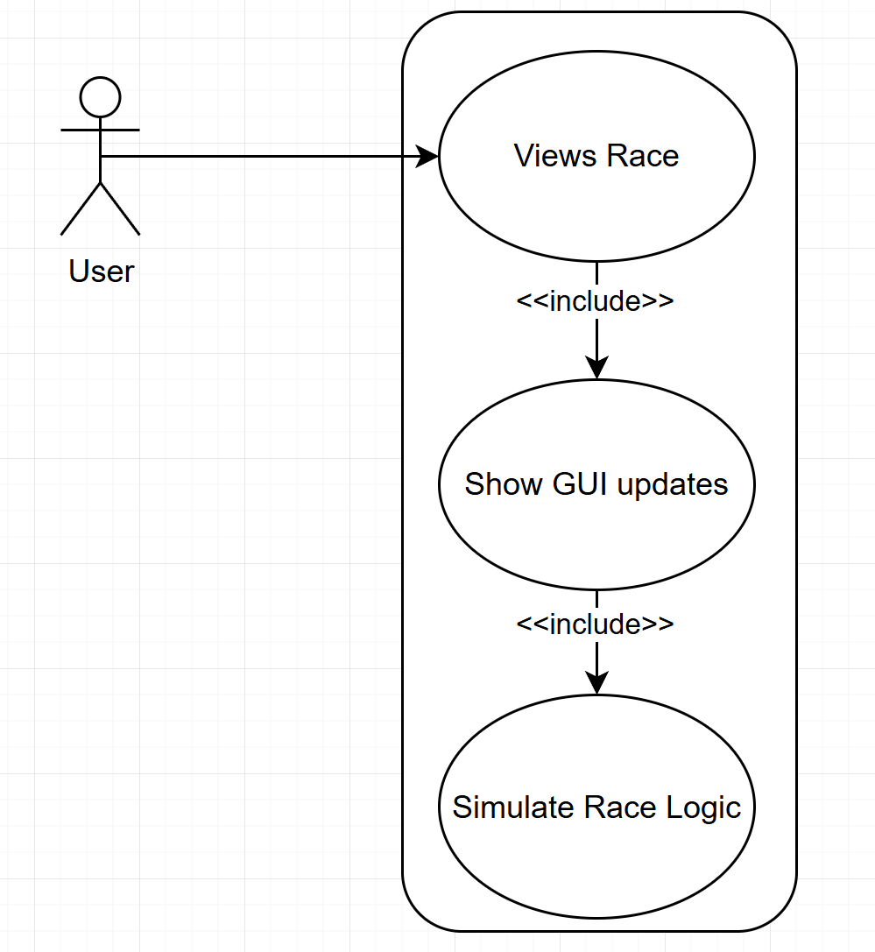

Scope
Display the current state of the race simulation while the event is in progress.

Description & Priority
The user requests to view the race and the system provides a visual representation of the race by displaying current driver positions, lap progress, race status, and relevant simulation information.
The interface receives updated race data during simulation execution and presents changes to the user. This allows the user to observe how the race develops over time, including changes in position and driver performance.
Priority: High

Flow Description

Precondition
- Driver and track data have been loaded.
- The race simulation has started.
- The graphical interface is available.

Activation
This use case begins when the user starts a race and live race information becomes available.

Main flow
- The system receives updated race data from the simulation process.
- The system processes current driver positions and race information.
- The system updates the race visualisation.
- The system displays lap information and race status.
- The system refreshes the interface after each simulation update.
- The system continues displaying race information until completion.

Alternate flow
- A1 – The user ends the race
  - The system triggers a race completion status in simulation
  - The system displays the race is over in the UI

Exceptional flow
- E1 – The interface fails to update
  - The system resets the interface
  - The system continues as normal

Termination
The race is over and nothing visual can occur.

Post condition
Live race display transitions to results

Requirement 4/UC-4 Configure race settings - Should

Use Case Diagram
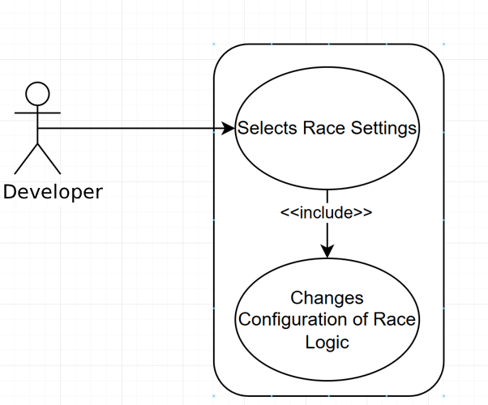

Scope
Allow race parameters to be configured before starting the simulation.

Description & Priority
The system supports configurable race parameters that determine the conditions used by the simulation engine when creating and running a race. Configuration values are provided through system settings before execution.
Priority: Medium

Flow Description

Precondition
- The application has started successfully.
- Required system configuration resources are available.

Activation
This use case begins when the developer opens the race configuration code.

Main flow
- The developer defines the required race parameters within the system configuration.
- The system loads the configured race parameters during initialisation.
- The system validates the configured parameters.
- The system creates the race simulation using the validated configuration.
- The user starts the race simulation.

Alternate flow
- A1 – The developer modifies configuration
  - The developer changes selected race options.
  - The system updates the configuration.
  - The use case continues from step 3 of the main flow.

Exceptional flow
- E1 – An invalid configuration selected
  - The system detects invalid race settings.
  - The system displays an error message.
  - The developer is prompted to select valid options.

Termination
The developer closes the race configuration code.

Post condition
A valid race configuration is available for the simulation engine.

Requirement 5/UC-5 View driver information - Should

Use Case Diagram
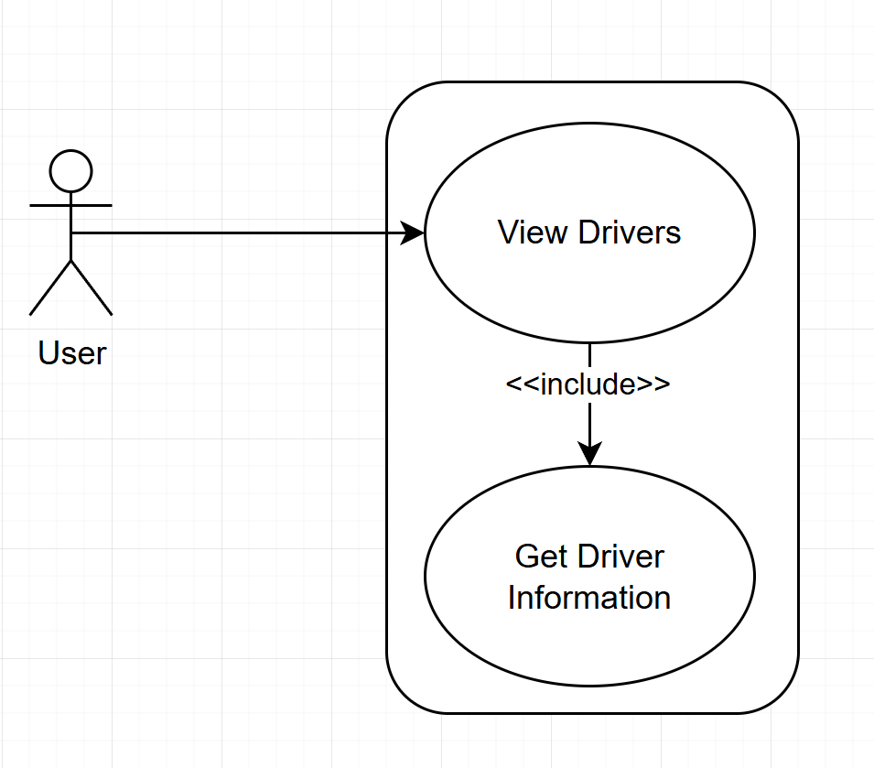

Scope
Display available information about drivers participating in the simulated race.

Description & Priority
The user requests the system provide access to driver information before and during the race. This allows the user to understand driver characteristics and provides additional context when observing race performance.
Priority: Medium

Flow Description

Precondition
- Driver data has been generated successfully.

Activation
This use case begins when the user views the driver information.

Main flow
- The system retrieves from generated driver objects stored in memory.
- The system displays the driver list.
- The system displays information relating to the drivers.
- The user reviews the displayed information.

Alternate flow
- A1 – The user wishes to continue the race without driver information
  - The driver information goes away

Exceptional flow
- E1 – The driver information fails to load
  - The system displays an error message.
  - The system reloads the information.

Termination
The user moves forward

Post condition
The driver information has been displayed and is available for user review.

Requirement 6/UC-6 Change Accessibility - Could

Use Case Diagram
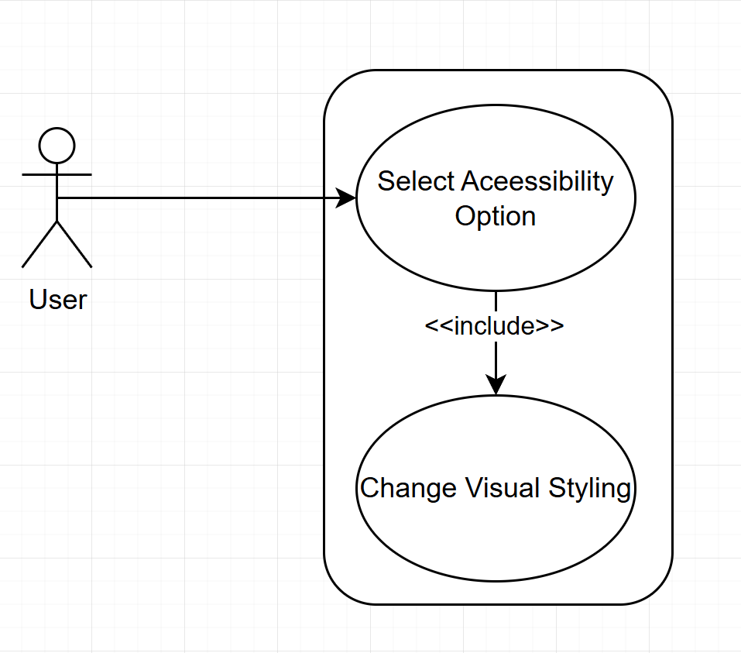

Scope
Allow the user to adjust interface options that improve accessibility and usability.

Description & Priority
The system provides optional accessibility settings that allow the user to modify interface behaviour according to their preferences. These settings improve usability but are not required for the core race simulation functionality.
Priority: Low

Flow Description

Precondition
- The application has started successfully.

Activation
This use case begins when the user opens the accessibility settings menu.

Main flow
- The system displays available accessibility options.
- The user selects preferred settings and saves.
- The system validates the selected settings.
- The system saves preferences to a JSON file.
- The system applies the configuration.
- The system updates the interface.

Alternate flow
- A1 – User resets to default
  - The system reverts to a predetermined default
  - The menu closes

Exceptional flow
- E1 – Settings fail to apply
  - The system displays an error message
  - The system reverts to a predetermined default

Termination
The accessibility settings menu closes.

Post condition
The selected accessibility preferences are active.

Data Requirements
Data Requirements help developers understand how data will be gathered and used, so that they can plan and build a database with functionality that supports the information flow. (Usability First, 2015)
Momentum uses structured data to allow different parts of the system to communicate while keeping the simulation logic separate from the graphical interface. The system uses persistent JSON storage for track definition and accessibility settings, while active simulation data is stored in memory during execution.
The primary data within the system consists of drivers, cars, tracks, race configuration, and telemetry information.
Driver data is used to represent the characteristics of each simulated driver. Each driver contains identifying information such as name, nationality, age, and racing archetype. Drivers also contain performance attributes including speed, handling, aggression, and consistency. These values influence how each driver behaves during simulation.
Car data represents the vehicle assigned to each driver. Each car is linked to one driver using a one-to-one relationship. This allows the race controller to track the performance of individual driver and car combinations throughout the race.
Track data defines the structure of the circuit used during simulation. Tracks are stored using JSON data, containing information such as the number of laps and checkpoint positions. Checkpoints are used by the simulation to determine race progress and calculate lap completion.
Telemetry data records the current state of the race while the simulation is running. This includes driver position, current lap, lap time, gap to leader, checkpoint progress, speed, tyre condition, fuel load, and race status. The telemetry system allows the user to understand the current state of the simulation rather than only viewing the final result.
Race configuration data stores user-selected settings before the simulation begins. This determines factors such as race distance and accessibility preferences.
The use of structured data allows the system to separate data storage from simulation logic. This improves maintainability and allows future development, such as additional tracks, drivers, and race features, without requiring major changes to the core system.

User Requirements
User requirements describe the services and behaviours that users require from the system. These requirements are translated into functional requirements that define the observable behaviour the software must provide. (Washizaki, 2025)
The intended users of Momentum are motorsport enthusiasts who are interested in understanding simulated race behaviour rather than directly controlling a vehicle. The system is designed to provide a clear overview of a race by presenting both visual information and numerical telemetry.
The main user requirements are:
• The user should be able to start and observe a simulated race without requiring technical knowledge of the underlying simulation.
• The user should be able to view driver information before a race begins to understand the characteristics of each participant.
• The user should be able to observe live race progression through a graphical representation of the circuit.
• The user should be able to view telemetry information to understand changes occurring during the race.
• The user should be able to view the final race classification and statistics after completion.
• The user should be able to adjust accessibility settings to improve usability.
The system focuses on reducing complexity for the user by presenting the information required to understand the race in a clear and organised manner.

Environmental Requirements
Environmental requirements are represented within IEEE Computer Society Software Engineering Body of Knowledge (SWEBOK) as nonfunctional requirements, specifically technology constraints. These requirements define the hardware, software, and infrastructure conditions required for the system to operate. SWEBOK identifies constraints such as operating systems, programming languages, database engines, and computing platforms as technology constraints. (Washizaki, 2025)
The application is designed as a desktop application using Python and PyQt6. It does not require specialised hardware and can operate using standard consumer computer systems.
Minimum hardware requirements:
- Dual-core processor
- 4GB RAM
- 500MB available storage
- Integrated graphics
- 1366x768 display resolution
- Mouse
Recommended hardware requirements:
- Quad-core processor
- 8GB RAM
- 1GB available storage
- Integrated or basic dedicated graphics
- 1920x1080 display resolution
- Mouse
Software requirements:
- Python 3.13
- PyQt6
- pytest for automated testing
- Operating system capable of running Python applications

Usability Requirements
Usability requirements for interface design should support primary users by ensuring the interface is efficient, intuitive, and low effort to use. Users should be able to complete goals quickly with few or no errors, learn and navigate the interface easily through clear buttons, headings, and help or error messages, and experience the interface as simple and approachable rather than intimidating, demanding, or frustrating.
(Usability First, 2015)
Usability requirements were informed by Nielsen's usability heuristics, which provide recognised principles for evaluating interface design. These heuristics were considered during the design of Momentum's graphical interface to ensure that users can understand race progression, access relevant information, and recover from potential errors. (Nielsen, 1994)
Momentum Requirement | Related Nielsen Heuristic
Clear navigation between race configuration, simulation, telemetry and results | Consistency and standards; Recognition rather than recall
Display current position, lap number and driver status clearly | Visibility of system status
User can observe race without understanding internal algorithms | Match between system and real world
Accessibility settings allow interface adjustment | Flexibility and efficiency of use
Error messages for invalid settings or failures | Help users recognise, diagnose, and recover from errors

Design & Architecture

System Architecture Overview
Momentum follows a layered architecture consisting of a graphical user interface layer, application logic layer, and data persistence layer. The architecture separates user interaction from simulation processing and data storage, allowing individual components to be developed and tested independently.
The user interacts with the system through the PyQt6 graphical interface. The interface communicates with the simulation engine through application services, which manage race configuration, driver behaviour, telemetry generation, and race progression. The simulation engine processes the race logic and stores persistent information using JSON.

Container Diagram
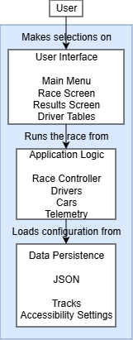
The container diagram shows the high-level shape of the software architecture and how responsibilities are distributed across it. It also shows the major technology choices and how the containers communicate with one another. It’s a simple, high-level technology focussed diagram that is useful for software developers. (C4 Model, n.d.)
Design and Architecture 1
The container diagram shown in Design and Architecture 1 represents the major runtime elements within Momentum and their communication paths. The system consists of three primary containers:
User Interface
The user interface provides all user interaction, including accessibility options, race monitoring, and results display. It does not directly access the data or perform simulation calculations.
Application Logic
The application controller manages communication between the interface and data persistence. It handles requests from the GUI, creates race sessions, and transfers simulation results back to the presentation layer.
Data Persistence
JSON is used to store track configuration and accessibility settings.

Component Diagram
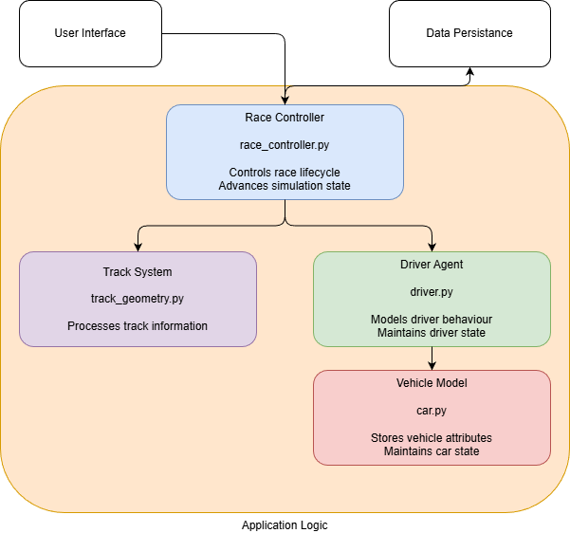
Design and Architecture 2
A component diagram shows how system components depend on one another. Dependency arrows indicate relationships between components, while the absence of an arrow suggests no direct dependency. (OMG UML, 2017)
Design and Architecture 2 shows Momentum’s component diagram with a focus on the application logic and four key components:
Race Controller
The Race Controller coordinates the execution of the race simulation. It initialises the race by loading the selected track, creating the driver and vehicle objects, and managing the simulation loop. During the race, it updates the state of each driver, processes telemetry information, and determines when the race has finished.
Track System
The Track System represents the circuit on which the race takes place. It loads track information from a JSON configuration file, including the track name, number of laps, sector layout, and any other race-specific parameters. This information is supplied to the Race Controller to govern race progression.
Driver Agent
The Driver Agent models the behaviour of an individual racing driver during the simulation. Each driver maintains attributes and current race state. During each simulation update, the driver agent determines its performance based on these characteristics and the current race conditions.
Vehicle Model
The Vehicle Model represents the performance characteristics of a driver's car. It stores runtime information such as tyre condition, fuel load, and other variables that influence lap performance. These values are updated throughout the race and are used by the Race Controller when calculating race progression.

Runtime Data
“Runtime refers to the period when a program is actively running and performing operations. It’s the moment your code moves from instructions written in files to actual behavior carried out in memory—calculations, UI updates, network calls, database queries, and everything in between.
While writing code defines what a program should do, runtime is when the program actually does it.” (Mimo, n.d.)

Momentum stores most application data in runtime memory rather than in a database management system. When a race begins, runtime objects such as drivers, vehicles, race state, and telemetry are created, then discarded when the application closes. Only configuration data, including track definitions and accessibility settings, is stored in JSON files so it can persist between sessions. This approach suits the project’s scope because the system simulates a single race and does not require long-term data storage. Avoiding a database keeps the application simpler to implement and reduces the overhead of persistent data management. However, this design has scalability limitations. If Momentum were expanded to support larger datasets, championship progression, historical race results, or career modes, relying on runtime memory would become inefficient and harder to manage. In that case, a database management system would provide persistent storage, improve data organisation, reduce dependence on runtime memory, and support efficient querying and retrieval of large volumes of data.

Data Flow
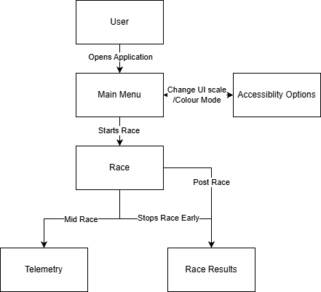
The user opens the application to the main menu, there they can change accessibility options and start the race.
Then within the race they can view the telemetry, watch the race to the end, and end the race early.
Whether they end the race early or see it through to the end,

Implementation

Telemetry

Pseudocode
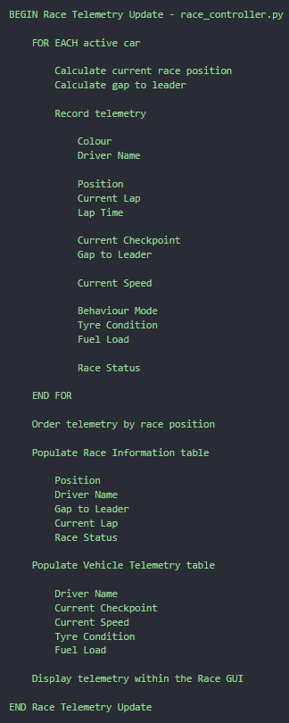
The idea of the project is to have a race simulation that is presented in a manner a user can understand, meaning as much information as possible should be visible as soon as it updates.
Telemetry 1
From Formula One, telemetry is used as a catchall term for all information that is gathered in real time. (Formula One, 2026)
It encompasses both the data the teams keep private to use for themselves and also what is presented to the audience, so they are aware of the shape of the race. A software project is perfect for this as everything about the inputs to the system is known, whereas in reality, there are many factors that, while measurable, are neither cost nor time effective to measure, such as every specific air movement.
To implement this, pseudocode (Telemetry 1) was first written to show how this feature should be carried out, along with the project file it would go into. This feature exists in both the backend and frontend. To avoid overburdening the page with screenshots, this section shows only the backend section; more was written for the frontend, but it is very similar, with the only differences being references to physical space.

Code Snippet
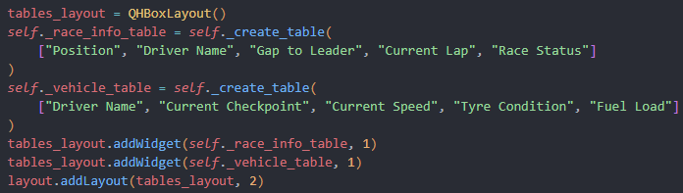
Telemetry 2
As seen in Telemetry 2, I create the tables using QHBoxLayout, this lines up widgets horizontally without additional need for manually placing each heading. (Qt Group, 2026)

Error
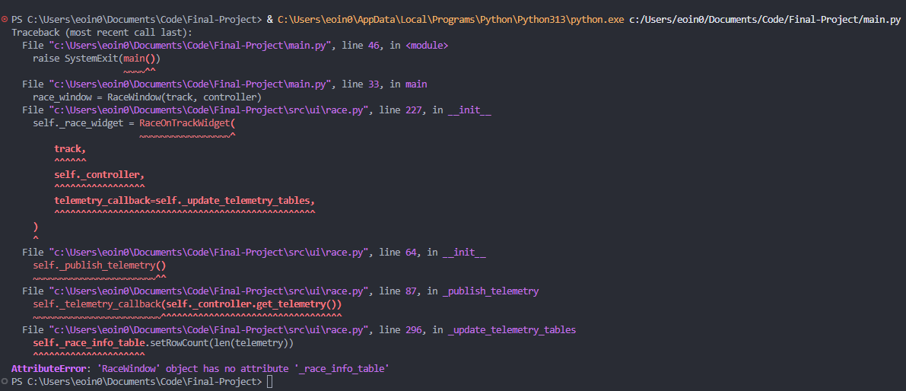
Telemetry 3
As seen in Telemetry 3, I have an attribute error stemming from line 64 - self._publish_telemetry(). The root cause of this is the telemetry is being called prior to the creation of tables, Telemetry 2 above shows I do have the creation of these tables within my code. This in an architecture issue rather than a missing element or mere typo. I have to consider when elements are called and created. I will now work on initialising all elements before calling upon said elements.

Fix
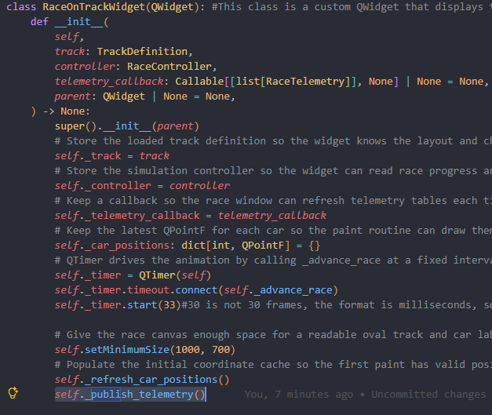
Telemetry 4
The offending line is highlighted, I merely had to remove it from the initialisation, I already had a line to populate the tables once they exist.

Cutoff
There is more telemetry that could be recorded and displayed, such as individual tyre wear, modelling tyre temperature, driver fatigue, track grip levels, mini sector times and comparisons to best sector or best lap. But for the purpose of a college project it was important to stay with a minimum viable product and not attempt too much and run out of time.

Driver Creation

Pseudocode
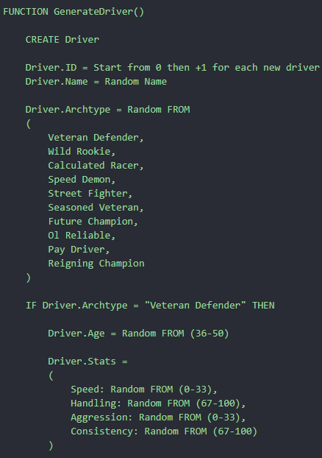
Drivers follow a pattern rather than a truly random set of attributes; There are 4 attributes and 10 driver personas. Age is affected by the persona.
Driver 1

Error
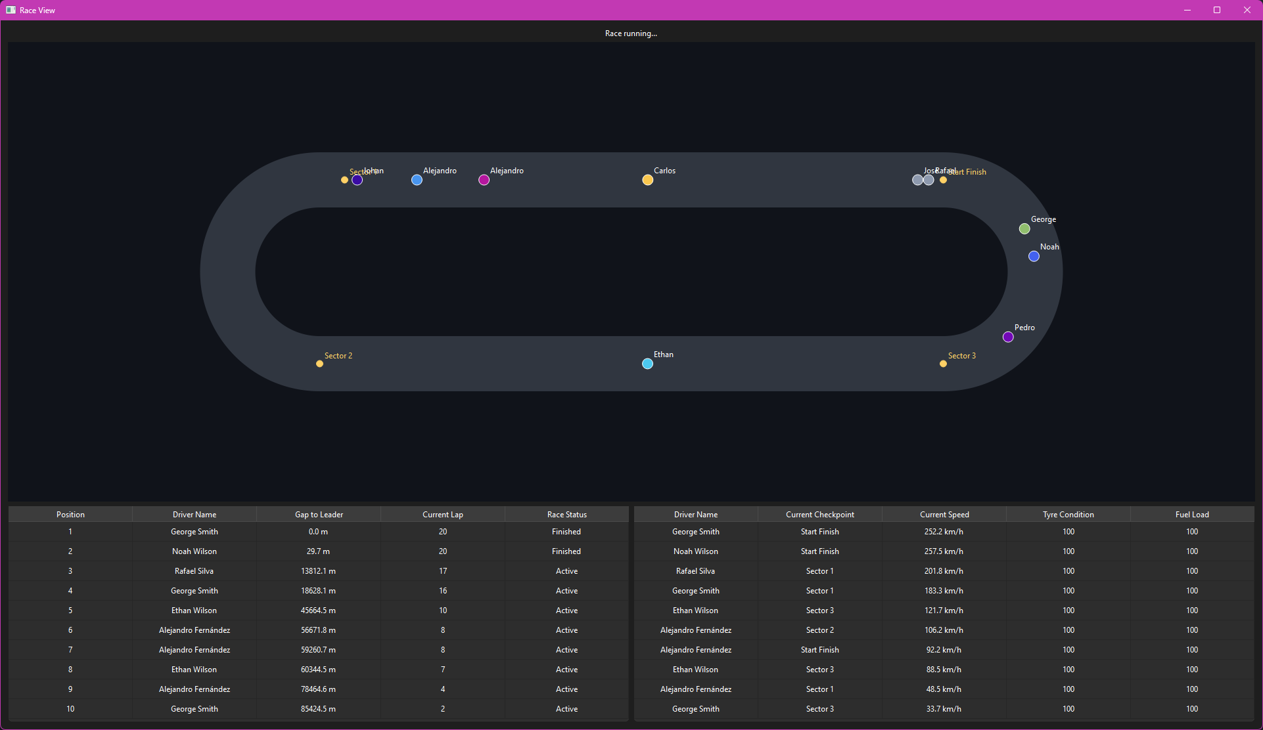
Driver 2
As shown in Driver 2, duplicate names arise as an issue, the fix involved adding a variable for used names then adding the selected name. There was also an issue with cars and drivers not being assigned in a 1 to 1 relationship. Changing from assigning from a pool each time to assigning by index solved that issue.

Code Snippet
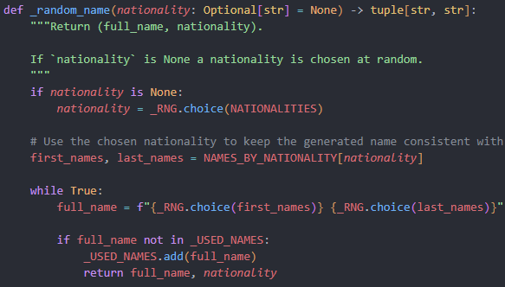
Driver 3
In Driver 3 you can see how names are assigned by nationality groups to make the simulation more immersive. This and the archetypes give some personification to the drivers to keep users’ attention.

Cutoff
There are many more countries and names that could be included in the project, as well as more attributes that are hyper focused on specific tasks such as trail braking, recovery from gravel, and more. Another big development would be driver progression over a career, how they train certain weaknesses or drop off with age. These were omitted for time.

Track

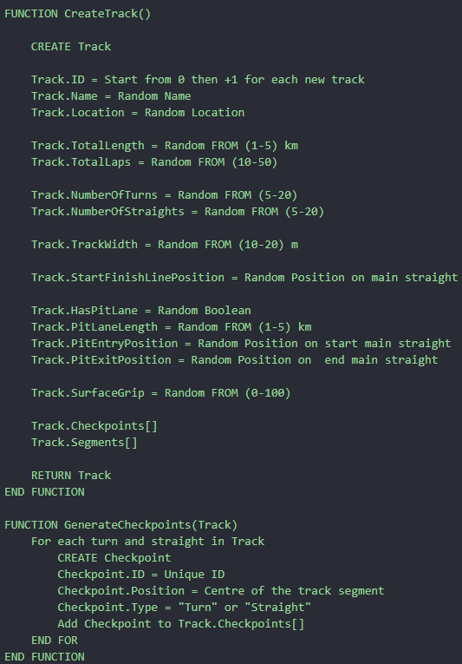
Pseudocode
Track 1
The graphical user interface is intended to show a race taking place visually, rather than relying only on timing screens and telemetry. Cars are displayed on a track so that the progress of the race can be observed directly. To support this, a custom racetrack needed to be implemented. In line with the scalability and modularity goals of the simulation, the track design began with a basic reusable structure, with procedural generation also considered as a possible extension. However, due to time constraints, procedural track generation was not completed, and the current implementation uses a basic oval-style loop within the code.

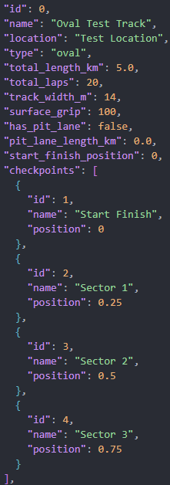
Code Snippet
In Track 2 you can see the actual JSON for the test track, it has 4 checkpoints that are positioned in quarters around the track.
Track 2

Error
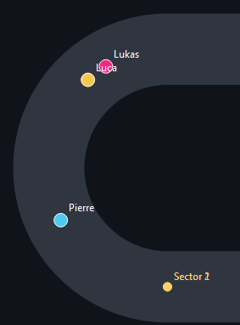
Track 3

Sector 1 and Sector 2 checkpoints placed in the same position as seen in Track 3. Sector 1 should be placed directly vertical from sector 2 but at the start of the turn.
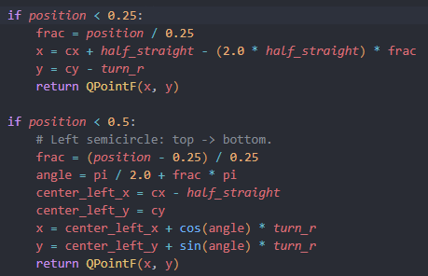
Track 4
As seen in Track 4, they should be in different positions as they have different logic assigned.

Fix
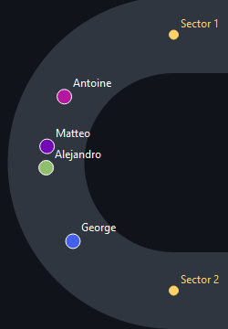
Now the sectors checkpoints are in the correct places. As shown in Track 5.
Track 5

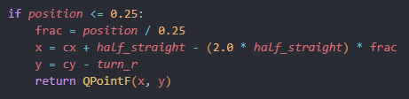
In Track 6, you can see the change from being less than to less than or equal to.

Track 6
The solution to this problem was found through trial and error. Setting the check to position < 0.24 was tried but then the checkpoint was offset by a minimal but noticable distance.

Cutoff
An element that was cut off for time was the implementation of pit lanes, there is a section in the JSON file and dataclass, but no code was added to implement it as a feature. Another track characteristic that could be worked on is different surfaces such as gravel or tarmac runoff, where there would be less grip and the possibility of retirements.

Graphical User Interface (GUI)

Main Menu
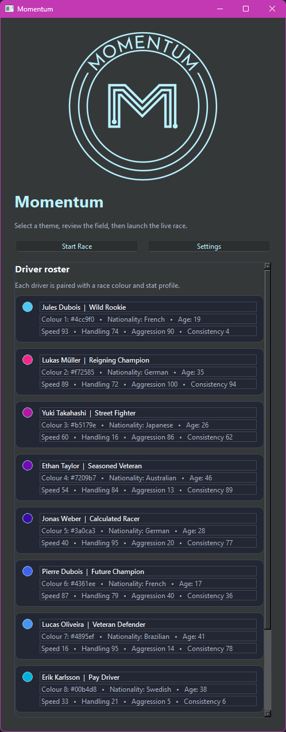
GUI 1 is the main menu. Here the user can see the drivers and all their information; colour, nationality, age, and attributes.
GUI 1
The user can also adjust accessibility settings.

Accessibility
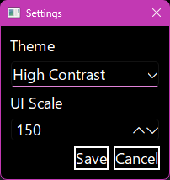
GUI 2
In GUI the accessibility settings are viewable. There are three themes and UI scales, default, high contrast, and colourblind, as well as 100%, 125% and 150%.

Accessibility in action
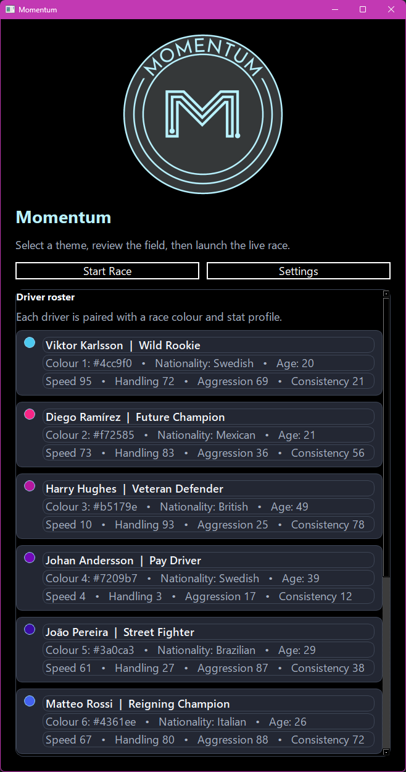
GUI 3
GUI 3 shows the main menu under the high contrast setting and 150% UI scale. This carries through to all screens and windows.

Racetrack
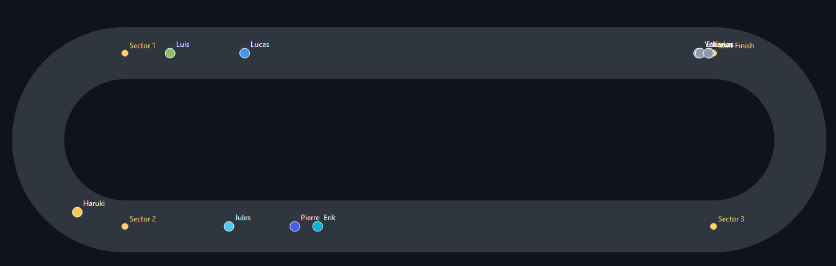
GUI 4
GUI 3 demonstrates the racetrack with the cars matching the names and colours from the main menu. The driver labels on track use their first names.

Telemetry
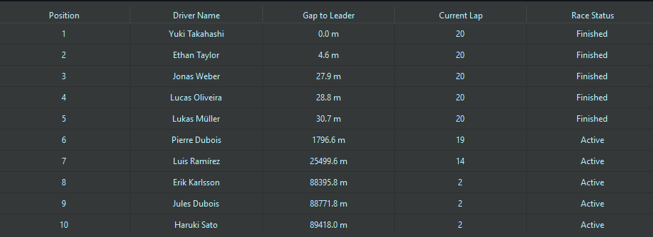
GUI 5
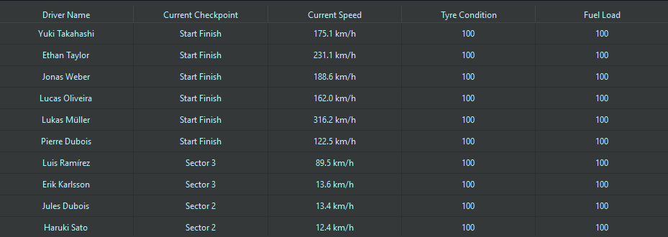
GUI 6
GUI 5 and GUI 6 show the telemetry of the drivers. Name, gap, lap, status, progress, speed, tyres, and fuel are the categories tracked.

Standings
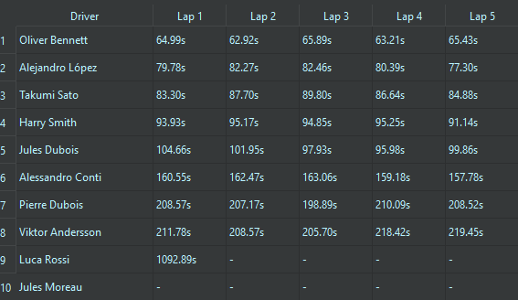
GUI 7
At the end of the race, you see the standings as shown in GUI 7. It shows the lap times of every driver for each lap and is sorted by finishing position.

Testing

Tools

pytest
pytest was used as the automated testing framework. The framework was selected because it provides automatic test discovery and clear reporting of successful and failed test cases. (pytest, 2015)
The project was configured as a Python package to allow test files to import source modules correctly during execution.
The src directory was converted into a Python package by adding __init__.py files. These files were added to the main source directory and relevant subdirectories, including:
- src/ __init__.py
- src/core/ __init__.py
- src/models/ __init__.py
The presence of these files allows Python to recognise the directories as packages and enables standard module imports within test files.
A pytest.ini configuration file was created in the project root directory. This file configures pytest to include the project root in the Python import path:
[pytest]
pythonpath = .
This configuration allows test files to import project modules directly, for example: from src.core.race_controller import RaceController without requiring manual modification of the Python system path.
Tests were organised using pytest's default naming conventions. Test files must begin with test_ or end with _test.py to be automatically detected by the pytest test discovery system.
The testing directory was organised into separate categories:
tests/
- unit/
  - test_driver_generate.py
- class/
  - test_race_controller_class.py
- integration/

- system/

Tests were executed from the project root directory using the command:
pytest
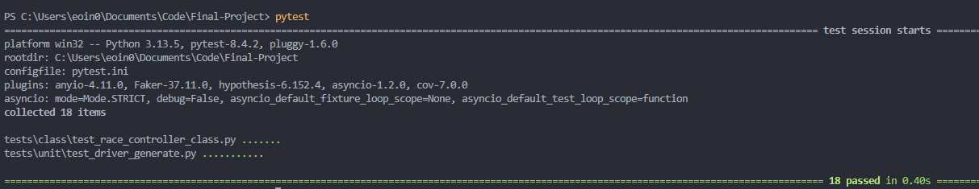
When executed, pytest automatically searches the test directories, identifies correctly named test files, runs each test function, and provides a summary showing the number of passed and failed tests. This process is shown in Testing 1.
Testing 1

pytest-qt
pytest-qt is a pytest plugin for testing PyQt5, PyQt6, and PySide6 applications.
It manages qApp creation when required through and provides methods for simulating user interactions, such as key presses and mouse clicks.
It functions with three APIs, in the following order; PySide6, PyQt6, and PyQt5. In order to force it to use pyqt6 which is what the project is built with, qt_api=pyqt6 needs to be placed in the pytest.ini file. (pypi, 2025)

Unit
Unit testing is testing method that pays specific attention to an individual component (unit) of code. (Powell & Smalley, 2025)
The idea is you have working code committed to the codebase instead of figuring out what works and what doesn’t right at the end, this concept is known as “shift left”.

Plan
The focus of automated unit testing was the driver generation module, ensuring that randomly generated drivers met all the requirements that was needed of them.
Test ID | Test Description | Component Tested | Test Method | Expected Result
UT-01 | Verify the correct number of drivers are generated | Driver generation | Automated pytest test | The function generates 10 driver objects, matching the race grid size
UT-02 | Verify generated drivers have assigned names | Driver generation | Automated pytest test | Every generated driver contains a non-empty name
UT-03 | Verify generated nationalities are valid | Driver generation | Automated pytest test | All driver nationalities exist within the predefined nationality list
UT-04 | Verify generated racing archetypes are valid | Driver generation | Automated pytest test | All driver archetypes exist within the predefined archetype list
UT-05 | Verify driver age constraints | Driver generation | Automated pytest test | All generated drivers are an age between 16 and 50
UT-06 | Verify driver speed attribute range | Driver statistics | Automated pytest test | Speed values are between 0 and 100
UT-07 | Verify driver handling attribute range | Driver statistics | Automated pytest test | Handling values are between 0 and 100
UT-08 | Verify driver aggression attribute range | Driver statistics | Automated pytest test | Aggression values are between 0 and 100
UT-09 | Verify driver consistency attribute range | Driver statistics | Automated pytest test | Consistency values are between 0 and 100
UT-10 | Verify driver ID uniqueness | Driver generation | Automated pytest test | No duplicate driver IDs are generated
UT-11 | Verify driver name uniqueness | Driver generation | Automated pytest test | No duplicate driver names are generated

Results
7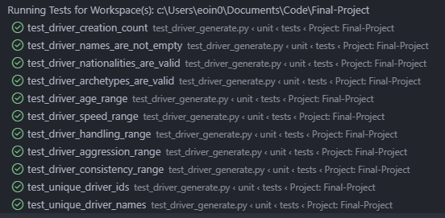
Testing 2
Testing 2 shows all tests have passed.

Class
Class testing lies somewhat between unit and integration testing, as a class is a fundamental unit of and object orientated programme. Yet a class also contains many methods that must be integrated with one another. (McGregor & Sykes, 2001)

Plan
This phase primarily focused on the RaceController class. The tests validated the behaviour of its methods and internal state management. Dependent classes, including Driver, Car, RaceTelemetry, and RaceResult, were used during execution to provide the required objects and verify that the controller operated correctly within the simulation environment.
Test ID | Test Description | Class Tested | Supporting Classes | Test Method | Expected Result
CT-01 | Verify class initialisation | RaceController | TrackDefinition | Automated pytest test | Controller initialises with the supplied track, car count and simulation settings
CT-02 | Verify race setup creates required objects | RaceController | Driver, Car | Automated pytest test | Setup creates the correct number of drivers and cars
CT-03 | Verify race state initialisation | RaceController | Car | Automated pytest test | Progress, lap time and lap start tracking dictionaries initialise correctly
CT-04 | Verify simulation step updates race state | RaceController | Driver, Car | Automated pytest test | Car progress and speed values update after one simulation tick
CT-05 | Verify telemetry generation | RaceController | Driver, Car, RaceTelemetry | Automated pytest test | Telemetry objects are created containing valid race information
CT-06 | Verify race ordering logic | RaceController | Car | Automated pytest test | Cars are sorted according to their current race progress
CT-07 | Verify race execution returns results | RaceController | Car, RaceResult | Automated pytest test | Completed simulation returns a finishing order containing all cars

Results
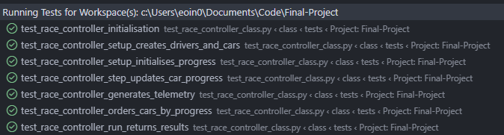
Testing 3
Testing 3 shows all tests passed.

Integration
Integration testing is a testing approach in which application components are joined and tested to evaluate how well they work together. Integration testing aims to prove that these assembled parts can interact correctly. (Powell & Smalley, n.d.)

Plan
The integration testing phase focused on the interaction between the RaceController and the MainMenu interface. The test verified that race data generated by the controller was successfully passed to the user interface, that the driver roster was populated correctly, and that the Start Race control triggered the connected race start callback.
Test ID | Test Description | Components Tested | Test Method | Expected Result
IT-01 | Verify race controller data integrates with the main menu interface | RaceController, MainMenu, DriverRosterWidget | Automated pytest test | Main menu loads successfully using generated race data, displays driver information, and the Start Race action triggers the connected callback

Results
Testing 4
Testing 4 shows main menu successfully integrates with the race controller.

System
System testing is an end-to-end testing approach used to evaluate an entire software system rather than individual components. It verifies that all integrated parts of the application work together correctly and that the system satisfies user and business requirements. (IBM, n.d.)

Plan
Test ID | Requirement Tested | Test Description | Test Method | Expected Result
ST-01 | FR1 - View race results | Complete a race simulation and view the final classification | Manual system test | The application displays the finishing order and race information for all participating drivers
ST-02 | FR2 - Simulate race progression | Start a race simulation and observe race progression | Manual system test | The race progresses using the implemented simulation logic until all cars complete the required race distance
ST-03 | FR3 - View live race | Launch a race and observe the live race interface | Manual system test | The user can view the ongoing race, including car positions and telemetry information
ST-04 | FR4 - Configure race settings | Load a race using the configured track data, including the predefined number of laps | Manual system test | The application correctly applies the configured race settings and completes the race using the specified distance
ST-05 | FR5 - View driver information | View the driver roster before starting a race | Manual system test | The application displays generated driver information, including names, archetypes and statistics
ST-06 | FR6 - Configure accessibility settings | Change accessibility options through the settings menu | Manual system test | The selected theme and interface scaling options are saved and applied correctly

Results

Race Results

There is information for every driver.

Race Progression
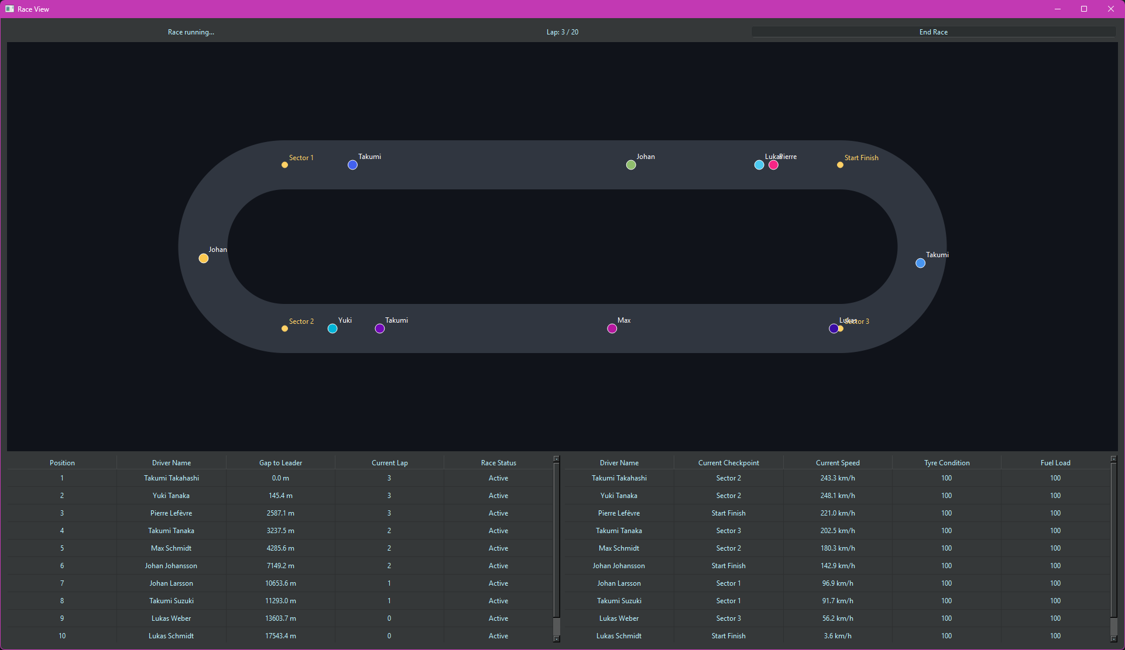
There is the current lap, whether the driver finished or not, and what their last checkpoint was.

Live Race

The cars move around on a circuit that the user can see.

Race Settings
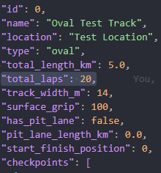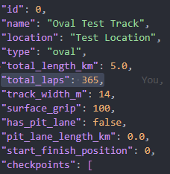
The laps set in the JSON are used for the race.

Driver Information
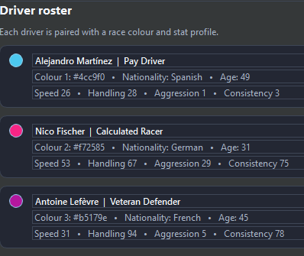
Viewable in the main menu.

Accessibility Settings


Evaluation
The completed Momentum system was evaluated using software quality and evaluation principles described within the IEEE Software Engineering Body of Knowledge (SWEBOK v4). The evaluation considered whether the implemented system satisfied the functional requirements defined during the requirements phase and assessed relevant software quality characteristics through verification, validation, performance analysis and architectural review. (Washizaki, 2025)
The evaluation was divided into functional suitability, correctness and reliability, performance efficiency, usability, maintainability and scalability. Evidence was collected from automated testing using pytest and pytest-qt, manual system testing, runtime measurements and analysis of the system architecture.

Functional Evaluation
Functional evaluation assessed whether the completed application satisfied the requirements established during the requirements analysis phase. The evaluation was performed using the system testing scenarios defined in Section 2.5.5, where each implemented feature was tested against its expected behaviour.
Requirement | Evaluation Method | Result
FR1 - View race results | Manual system test | Passed
FR2 - Simulate race progression | Manual system test | Passed
FR3 - View live race | Manual system test | Passed
FR4 - Configure race settings | Manual system test | Passed
FR5 - View driver information | Manual system test | Passed
FR6 - Configure accessibility settings | Manual system test | Passed
All six functional requirements were successfully implemented and validated. The completed system supports the intended user workflow by allowing users to configure application options, inspect generated drivers, execute a race simulation, monitor race progression through telemetry and review the final classification.
The results demonstrate that the minimum viable product objectives were achieved. However, the evaluation only considers the implemented project scope and does not indicate that the application contains all functionality expected from a complete motorsport management simulation.

Correctness and Reliability Evaluation
Correctness evaluation focused on verifying that individual components behaved according to their expected specifications and whether integrated components communicated correctly. This evaluation was supported by the automated testing activities described in Section 2.5.
The completed automated test suite consisted of unit, class and integration tests.
Testing Category | Number of Tests | Passed | Failed
Unit Testing | 11 | 11 | 0
Class Testing | 7 | 7 | 0
Integration Testing | 1 | 1 | 0
Total | 19 | 19 | 0
Unit testing demonstrated that driver generation produced valid driver objects according to the defined constraints, including valid attributes, age ranges and uniqueness requirements. Class testing verified that the RaceController correctly managed race initialisation, simulation updates, telemetry generation and result generation.
Integration testing confirmed that the simulation logic successfully communicated with the graphical interface. The main menu was able to receive generated race data and trigger race execution correctly.
The successful completion of all automated tests provides evidence that the implemented components operate according to their intended behaviour. However, testing cannot guarantee the absence of all defects, as only the implemented test cases and scenarios were evaluated.

Performance Evaluation
Performance evaluation assessed whether the system could execute the intended race simulation efficiently within the constraints of the project scope. The evaluation focused on simulation execution time, resource consumption and graphical responsiveness.
The system was tested using the configured race environment consisting of ten driver agents. Performance measurements were collected by executing the same race configuration multiple times and recording the execution duration.
Measurement | Result
Number of drivers | 10
Number of laps | 20
Average simulation completion time | 60s
Average memory usage | 40MB
The results indicate that the current implementation is suitable for the intended prototype scale. The simulation only manages a limited number of agents and therefore does not require complex optimisation techniques or external storage systems. The in-game time is factored at around 30* real time.
The current architecture stores active race objects in runtime memory, which provides fast access and reduces implementation complexity. This approach is appropriate for a single-race prototype where historical persistence is not required. However, this design would become less suitable as the system grows because larger simulations, championship history and persistent player progression would increase memory requirements.

Usability Evaluation
Usability evaluation considered whether users could successfully interact with the system and understand the information presented by the graphical interface. This evaluation was based on manual system testing and analysis of the implemented user interface features.
The application provides a clear workflow consisting of:
- Viewing generated driver information.
- Configuring accessibility settings.
- Starting the race simulation.
- Monitoring live race information.
- Reviewing final race results.
The interface provides visibility of system state through live race progression, telemetry information and race classification output. Accessibility options improve usability by allowing users to adjust interface settings according to their preferences.
A limitation of this evaluation is that formal user testing with external participants was not performed. Therefore, usability conclusions are based on functional interaction testing and developer evaluation rather than statistical user feedback.

Nielsen Heuristic Evaluation
Heuristic | Evaluation
Visibility of system status | The live race screen provides continuous feedback through car positions, lap progress, telemetry data, and race status.
Match between system and real world | Motorsport terminology such as laps, positions, gaps and driver names is used instead of internal simulation terminology.
Consistency and standards | The selected accessibility theme and UI scaling are applied across all screens.
Recognition rather than recall | Driver information and telemetry are displayed directly rather than requiring users to remember previous states.
Error prevention | Configuration validation prevents invalid race settings from being used.
The heuristic evaluation was performed by the developer rather than through an independent usability review.

Maintainability Evaluation
Maintainability was evaluated through analysis of the system architecture and separation of responsibilities between components.
The application separates major responsibilities into independent modules:
- Graphical interface components handle user interaction and visualisation.
- RaceController manages simulation execution.
- Model classes represent drivers, cars and telemetry data.
- Configuration files store adjustable race parameters.
This modular design reduces coupling between components and allows individual areas of the system to be modified without requiring changes throughout the entire application. For example, changes to race simulation logic can be implemented independently from graphical interface components.
The architecture also supports future development by providing clear locations for additional functionality. However, some limitations remain because the current system does not include persistent data storage or database abstraction.

Scalability Evaluation
Scalability evaluation considered how effectively the current architecture could support future expansion beyond the project scope.
The completed prototype has several intentional limitations:
Area | Current Implementation
Drivers | Fixed 10-driver grid
Race structure | Single race simulation
Storage | Runtime objects and JSON configuration files
Tracks | Limited configured track data
Progression | No championship or historical records
These limitations were introduced to maintain a realistic project scope and allow focus on the core simulation and visualisation features.
For a larger-scale application, additional infrastructure would be required. A database could be introduced to store historical races, driver progression and championship information. The simulation architecture could also be expanded to support additional tracks, larger grids and more complex race behaviour.
The existing separation between simulation logic, user interface and data models provides a foundation for these future improvements, although significant additional development would be required before the system could operate at commercial-scale complexity.

Overall Evaluation
The evaluation demonstrates that Momentum successfully achieved the objectives defined for the minimum viable product. All functional requirements were implemented, all automated tests completed successfully, and the system demonstrated appropriate performance for its intended prototype scale.
The main strengths of the system are its modular architecture, separation between simulation and interface components, and successful implementation of an agent-based race simulation with telemetry visualisation.
The primary limitations are the restricted simulation scope, lack of persistent storage and simplified race mechanics. These limitations are consistent with the project objectives and provide clear areas for future development. Overall, the evaluation indicates that Momentum provides a functional and maintainable foundation for further expansion into a more complete motorsport management simulation.

Conclusions
Momentum successfully demonstrates the development of an agent-based motorsport management simulation capable of modelling a simplified race environment. The project achieves its primary objective of creating an interactive application where autonomous driver agents compete in a simulated race, with race progress, telemetry information, and final results presented through a graphical user interface. The system applies software engineering principles including modular design, separation of concerns, deterministic testing, and component-based development to produce a maintainable and extensible application.
A key strength of the project is the implementation of driver agents with different archetypes. Each driver is represented with predefined characteristics that influence their simulated performance, creating variation between competitors and preventing races from producing identical outcomes. This provides a more realistic simulation compared to a system where all competitors follow identical behaviour. The use of an agent-based approach also provides a flexible foundation, allowing additional driver attributes or simulation mechanics to be introduced in future versions without requiring a complete redesign of the system.
Another advantage is the deterministic simulation approach through the use of seeded random number generation. This allows race scenarios to be reproduced consistently, which improves reliability during development and testing. The separation between the race simulation logic, telemetry system, and graphical interface also improves maintainability, as changes to one component can be made with reduced impact on other parts of the application. The graphical interface further improves accessibility by allowing users to configure and observe a race without requiring direct interaction with the underlying implementation.
Despite these strengths, the project has several limitations. The race simulation uses a time-gap based approach rather than a full physics-based vehicle model. This decision was appropriate for the project scope, as implementing realistic vehicle physics would introduce significant additional complexity, but it means the simulation does not represent factors such as racing lines, collisions, aerodynamic effects, or detailed vehicle dynamics. The system therefore focuses on simulating race outcomes and competitor variation rather than accurately reproducing the physical behaviour of motorsport.
The current implementation is also limited in the number of motorsport management features available. Features such as tyre degradation, fuel management, pit stop strategies, driver development, financial management, and championship progression were not included within the final project scope. As a result, the user interaction is focused primarily on observing the simulation and viewing results rather than managing a complete motorsport organisation.
Another limitation is the current data management approach. Active race information is primarily maintained during runtime, which is suitable for a small-scale simulation with a limited number of drivers and races. However, this approach would become less efficient as the application expands to support larger datasets, historical race records, multiple championships, or persistent user profiles. A future version could introduce a more extensive database architecture to store race history, player progress, and statistical analysis while reducing reliance on runtime memory.
The project could be expanded through several areas of future development. Additional simulation mechanics, such as tyre wear, fuel consumption, pit strategies, and more advanced driver decision-making, could increase the realism of race outcomes. The introduction of more complex management systems and persistent data storage could also transform the application from a single-race simulator into a larger motorsport management platform. Furthermore, more advanced artificial intelligence techniques could be explored to create more dynamic driver behaviour.
Overall, Momentum provides a functional foundation for an extensible motorsport simulation system. While the project intentionally simplifies several aspects of real-world motorsport, it successfully demonstrates how autonomous agents, simulation logic, telemetry processing, and graphical interfaces can be combined to create an interactive software application. The completed system meets the defined project objectives while providing clear opportunities for future enhancement.

Further Development or Research
With additional time and resources, the project would continue in the direction of a more advanced motorsport simulation system. The primary focus would remain on improving the accuracy and realism of the race simulation rather than expanding into a traditional management game.
A significant area of future development would be improving the visual and audio experience. Higher quality vehicle models, circuit environments, animations, and user interface elements would improve immersion and allow the simulation to better represent different motorsport series. Audio features such as engine sounds, environmental effects, and race events could be integrated through licensed sound libraries or commercially available assets if the project were developed into a commercial product.
The underlying vehicle simulation could also be expanded from the current simplified model into a more advanced physics-based system. Currently, vehicles follow predefined racing lines with performance adjustments based on driver archetypes and simulation parameters. Future work would investigate vehicle dynamics, including the relationship between steering input, tyre grip, vehicle rotation, and handling characteristics. This would require implementing more realistic turning behaviour and researching concepts such as the relationship between steering angle and vehicle slip dynamics. Different track surfaces could also be introduced, each providing different grip characteristics and affecting vehicle performance.
Tyre simulation would be another major area of development. Future versions could implement dynamic tyre degradation, where grip changes throughout a race based on usage, driving style, and environmental conditions. Fuel consumption could also be modelled, allowing vehicle weight and performance to change as fuel levels decrease. These additions would allow driver agents to make more complex decisions during races rather than relying primarily on predefined behaviour.
The simulation architecture could also be expanded beyond individual races. A long-term championship system could be introduced, with persistent storage for drivers, teams, vehicles, and historical results. A lightweight database solution such as SQLite would be suitable for storing this information because the expected dataset size would not require a larger database system. This would allow the simulation to maintain progression between events while keeping the architecture simple and appropriate for the project scope.
Additional entities could also be introduced, including teams, engineers, and other staff members who influence vehicle performance and race outcomes. However, the focus would remain on modelling the behaviour of racing systems rather than introducing extensive economic or game management mechanics. Features such as team finances, sponsorships, and marketing systems could be explored, but would require careful consideration to ensure the project remains a simulation rather than becoming a traditional motorsport management game.
Further research could also investigate more advanced autonomous driver agents. Instead of drivers primarily reacting through fixed behaviours, agents could make decisions based on race conditions, vehicle characteristics, tyre state, fuel level, and strategic objectives. This would create a more dynamic simulation where different drivers and vehicles produce varied outcomes through emergent behaviour.
Overall, future development would aim to transform the current prototype into a more complete motorsport simulation platform, combining realistic vehicle physics, intelligent driver agents, improved presentation, and persistent simulation data while maintaining the project's core objective of observing and modelling racing systems.

References
Agile Business Consortium, 2026. What is MoSCoW Prioritization?. [Online]
Available at: https://www.agilebusiness.org/resource/what-is-moscow-prioritization/
[Accessed 16 July 2026].
C4 Model, n.d. Container diagram | C4 model. [Online]
Available at: https://c4model.com/diagrams/container
[Accessed 25 July 2026].
Embarcadero, 2016. UML 1.5 Use Case Diagram Definition. [Online]
Available at: https://docwiki.embarcadero.com/RADStudio/Athens/en/UML_1.5_Use_Case_Diagram_Definition
[Accessed 17 July 2026].
Formula One, 2026. F1 Glossary (P-T). [Online]
Available at: https://www.formula1.com/en/latest/article/f1-glossary-p-t.GBhLQtpeu9b8LrK5VM0F1
[Accessed 22 July 2026].
Geeks for Geeks, 2026. Component Based Diagram - Unified Modeling Language (UML). [Online]
Available at: https://www.geeksforgeeks.org/software-engineering/component-based-diagram/
[Accessed 25 July 2026].
GitHub Docs, n.d. What is GitHub?. [Online]
Available at: https://docs.github.com/en/get-started/start-your-journey/what-is-github
[Accessed 31 July 2026].
Git, n.d. About Git. [Online]
Available at: https://git-scm.com/about
[Accessed 31 July 2026].
IBM, n.d. What is system testing?. [Online]
Available at: https://www.ibm.com/think/topics/system-testing
[Accessed 30 July 2026].
IEEE, n.d. Software Requirements Specifications. [Online]
Available at: https://www.computer.org/resources/software-requirements-specifications
[Accessed 30 July 2026].
McGregor, J. D. & Sykes, D. A., 2001. A Practical Guide to Testing Object-Oriented Software. Boston: Addison-Wesley Professional.
Mimo, n.d. Runtime: Definition, Purpose, and Examples. [Online]
Available at: https://mimo.org/glossary/programming-concepts/runtime
[Accessed 31 July 2026].
Nielsen, J., 1994. 10 Usability Heuristics for User Interface Design. [Online]
Available at: https://www.nngroup.com/articles/ten-usability-heuristics/
[Accessed 31 July 2026].
OMG UML, 2017. OMG® Unified Modeling Language®. 2.5.1 ed. s.l.:OMG UML.
Powell, P. & Smalley, I., 2025. What is unit testing?. [Online]
Available at: https://www.ibm.com/think/topics/unit-testing
[Accessed 29 July 2026].
Powell, P. & Smalley, I., n.d. Integration testing, defined. [Online]
Available at: https://www.ibm.com/think/topics/integration-testing
[Accessed 29 July 2026].
pypi, 2025. pytest-qt 4.5.0. [Online]
Available at: https://pypi.org/project/pytest-qt/
[Accessed 30 July 2026].
PYPI, 2026. PyQt6 6.11.0. [Online]
Available at: https://pypi.org/project/PyQt6/
[Accessed 31 July 2026].
pytest, 2015. pytest: helps you write better programs. [Online]
Available at: https://docs.pytest.org/en/stable/
[Accessed 29 July 2026].
Python, n.d. dataclasses — Data Classes. [Online]
Available at: https://docs.python.org/3/library/dataclasses.html
[Accessed 31 July 2026].
Python, n.d. os — Miscellaneous operating system interfaces. [Online]
Available at: https://docs.python.org/3/library/os.html
[Accessed 31 July 2026].
Python, n.d. pathlib — Object-oriented filesystem paths. [Online]
Available at: https://docs.python.org/3/library/pathlib.html
[Accessed 31 July 2026].
Python, n.d. random — Generate pseudo-random numbers. [Online]
Available at: https://docs.python.org/3/library/random.html
[Accessed 31 July 2026].
Qt Group, 2026. Qt Group Documentation. [Online]
Available at: https://doc.qt.io/qt-6/qhboxlayout.html
[Accessed 24 July 2026].
Usability First, 2015. Usability First - About Usability - Requirements Specification | Usability First. [Online]
Available at: https://www.usabilityfirst.com/about-usability/requirements-specification/index.html
[Accessed 17 July 2026].
Visual Studio Code, n.d. The open source AI code editor. [Online]
Available at: https://code.visualstudio.com/
[Accessed 31 July 2026].
Washizaki, H., 2025. Guide to the Software Engineering Body of Knowledge. 4.0a ed. s.l.:IEEE.

Appendices
This section should contain information that is supplementary to the main body of the report.

Project Proposal


National College of Ireland

Project Proposal
Momentum
11/12/25

Computing
Software Development
2025/2026
Eoin Andrew Fitzsimons
X23151374
X23151374@student.ncirl.ie

Objectives
Momentum aims to design and implement a prototype motorsport management simulator that captures the scale, depth, and unpredictability of real-world racing ecosystems. Unlike existing titles, which currently focus on a limited range of disciplines (e.g., Formula 1 and limited feeder systems), it will model a wide variety of racing disciplines, each with its own unique challenges and culture. For example, rally racing will feature dynamic terrain and weather, requiring teams to adapt strategies for gravel, tarmac, or snow. Endurance racing will simulate human factors such as driver fatigue, teamwork, and mechanical reliability over long events. Street racing will emphasise customisation, driver personality, and the underground culture that shapes rivalries and alliances. By capturing these distinctions, the simulator will aim to represent a more varied and context-sensitive motorsport environment, where each series presents different management challenges.
The objective is to simulate a persistent game world where events unfold across all leagues, regardless of whether the player is directly involved. By doing so, the system mirrors the emergent qualities of Football Manager, supporting diverse career trajectories that may differ across playthroughs.
A further objective is to offer a high degree of customisation. Players will be able to modify or generate new teams, drivers, and competitions. Procedural generation will be a cornerstone, enabling large-scale fictional ecosystems that feel authentic while avoiding licensing restrictions.
The project will demonstrate implementation across key areas including simulation design and AI-driven decision-making. The intended prototype will model core systems such as driver progression, economic management, league standings, and race outcomes, with a focus on achieving computational efficiency.
The project’s objective is to produce a management simulator that can serve as a foundation for future extension. It seeks to address an identified gap in current games by emphasising simulation depth and customisation, rather than prioritising graphical fidelity.

Background
My passion for motorsport spans a wide range of disciplines, from open-wheel racing to rally, endurance, and street racing. While some recent games, such as The Crew Motorfest, successfully capture the unique feel and culture of different racing series, they focus on driving experiences rather than management. Existing management games, on the other hand, tend to concentrate on a single discipline or lack the depth and variety needed to authentically represent the full spectrum of motorsport. No current title combines the breadth of racing types, the distinctiveness of each discipline, and the emergent, persistent world of a management simulation. This project seeks to address that gap by integrating the unique characteristics of multiple racing series into a single, dynamic management experience.
Having spent extensive hours in Football Manager, I have experienced the appeal of large, complex simulations that generate emergent stories. Despite having a stronger interest in Formula 1 and motorsport generally than in football, I find myself drawn more to Football Manager than to existing motorsport management titles. This reveals an important insight: the attraction lies not in the sport itself, but in the richness of the simulated world.
By comparison, current motorsport titles such as F1 Manager and Motorsport Manager are limited. Their focus is on presentation and visuals rather than world depth. The lack of customisation and the narrow scope of simulated leagues lead to repetitive experiences over time.
This project seeks to address this gap by exploring how the thematic appeal of motorsport can be combined with the systemic depth characteristic of Football Manager. The objectives outlined in Section 1.0 will be met by designing algorithms that support persistent multi-league simulation, driver development models, and financial/strategic systems. Procedural content generation will be used to overcome licensing limitations and create a fictional but believable motorsport ecosystem.

State of the Art
Current motorsport management titles include Motorsport Manager (2016) and F1 Manager (2022–2024). These games present detailed races and authentic visuals, but their simulation depth is fundamentally limited. Driver development is linear and predetermined, making long-term play predictable. Once a player has learned the optimal strategies, the outcomes become repetitive. In contrast, Football Manager maintains replayability by simulating an immense global ecosystem of leagues, players, and staff, where no two careers are the same. This difference highlights the gap between motorsport management games and the broader standard of emergent sports simulations.
Another limitation of existing motorsport titles is their lack of customisation. Players cannot easily expand leagues, create fictional scenarios, or reshape the competitive environment. The games are tightly constrained by licensing agreements and static structures, which prevents the freedom that makes Football Manager engaging. Furthermore, the game worlds are small in scale, restricted to a handful of categories such as Formula 1 or Formula 2, with little simulation occurring outside the top tiers. By comparison, Football Manager tracks hundreds of leagues and thousands of clubs across multiple nations, with events unfolding regardless of direct player involvement.
This project aims to distinguish itself by adopting that philosophy. The simulation will extend beyond open-wheel racing, with multiple tiers within each discipline. Every league will progress whether the player manages there or not, creating a sense of a living world. Because official licensing is not available, all teams, drivers, and championships will be procedurally created, which also allows experimentation with unique structures, rivalries, and narratives. By prioritising breadth, depth, customisation, and emergent systems, this project will investigate how principles seen in Football Manager’s large-scale simulation might be adapted to a motorsport context.
It is worth noting that some recent non-management racing games, such as The Crew Motorfest, have made significant strides in capturing the unique feel, culture, and challenges of different racing disciplines. These titles demonstrate that it is possible to authentically represent the diversity of motorsport, from rally to endurance to street racing. However, they focus on the driving experience and do not offer the persistent, emergent management simulation that is central to this project. No current management title integrates the breadth of racing types, the distinctiveness of each discipline, and a persistent simulation world. This project aims to explore how these elements can be combined within a prototype, developing a management simulator that reflects both the variety and complexity of motorsport ecosystems.

Technical Approach
Momentum is being built using agile software principles. The system is organised into three main parts: the Simulation Engine, Database Management, and the Front-End Interface. Each part works together to create a realistic and engaging motorsport management experience.

Simulation Engine
The simulation engine is the heart of the system. Its design is inspired by popular motorsport management games and research into multi-agent systems. The engine handles things like how drivers improve over time, how teams manage their finances, how races are decided, and how multiple leagues can run at once. Race results are calculated using Monte Carlo simulations, which take into account driver skills, car performance, track details, weather, and random events. The financial side uses probability-based models to reflect real-world unpredictability, such as changes in sponsorship or unexpected costs. This means, for example, that a team with less money might have to take more risks with their strategy, which can change how the whole league plays out.

Database Management
The database management system is responsible for creating and storing all the teams, drivers, tracks, and championships. It uses algorithms to generate these elements based on certain rules and probabilities, ensuring that each league is balanced and diverse. Driver traits like skill, temperament, and fatigue are set according to the needs of the league. Tracks are created with different weather, locations, and surfaces, which all affect how races play out. Team budgets and resources are also assigned by the database, helping to create a dynamic and evolving competition. The system keeps an eye on things like driver diversity and league balance, making automatic adjustments to keep the game fair and interesting. All aspects of content creation and generation are managed here, so references to procedural generation are now part of database management.

Front-End Interface
The front-end interface, built in Python, displays race data, standings, driver stats, and financial dashboards. It shows the results of simulations and AI decisions, and updates in real time as the game progresses. When users make decisions or change strategies, these are sent to the back end, which updates the league data. The interface provides instant feedback on how the league is evolving and how the AI and database management systems are affecting the game.

Iteration, Feedback, and Scalability
The development plan is broken into clear phases, with regular feedback and review. Progress is measured by tracking things like driver development, AI improvements, financial stability, and the diversity of the database-generated content. The system is designed to be modular, so new features or motorsport types can be added without having to rebuild everything. Data is stored efficiently to allow for long-term, multi-league play, making Momentum a robust and replayable motorsport management simulator.

Technical Details
Momentum uses Python for both the front-end dashboards and the back-end simulation logic and database management. The system relies on NumPy for fast calculations, Pandas for handling data, and SciPy for advanced statistics. The database uses SQLite to store all the information about drivers, teams, tracks, and championships, making it easy to save and load multi-season histories. All content creation and generation is handled by the database management system.

Race Outcome Simulation
Race results are produced by a real-time, agent based engine. Each driver is modelled as an autonomous AI agent that makes decisions on every simulation tick, targeting a frame rate of about 30 ticks per second. Agents consider their attributes, car condition, tyre state, fuel, nearby rivals, team orders and track conditions when choosing actions such as attack, defend, overtake or conserve. Discipline specific rules are applied by the engine to reflect differences between single seater, rally, endurance and other formats. Randomness is retained for low probability events such as mechanical failures or incidents so outcomes remain unpredictable, but most race behaviour emerges from agent interactions rather than repeated sampling. Performance sensitive results are cached where appropriate to keep leaderboards and UI queries responsive.

Driver Progression
Driver attributes like speed, consistency, aggression, adaptability, and fatigue are tracked as numbers that can change over time. How a driver develops depends on their past results, which are stored in the database. Growth and decline are modelled using probability-based functions, so each driver's career is unique. Fatigue and injuries are also tracked, with recovery periods built in, making each season different and challenging.

Data Management
All teams, drivers, tracks, and championships are created and managed by the database management system. It uses algorithms to ensure that everything is balanced and diverse, with different locations and themes for tracks and championships. Before anything is saved, the system checks that the league will be fair and interesting. This approach makes every playthrough unique and replayable, and all content generation is now part of database management.

Performance Optimisation & Integration
The Python backend uses fast, vectorised calculations and keeps frequently used data in memory for speed. League states are saved at the end of each season, so progress is never lost. The system uses JSON to keep everything in sync between the front end and database management. The design makes it easy to add new features or motorsport types in the future, without having to change the core of the game.

Special Resources Required

Hardware Requirements
Momentum's Python GUI and simulation backend have modest hardware requirements. For typical development and use:
- Minimum Requirements:
CPU: Dual-core processor (e.g., Intel i3 or AMD equivalent)
RAM: 4 GB
Storage: 500 MB free disk space
GPU: Integrated graphics (no dedicated GPU required)
Display: 1366x768 resolution
- Recommended Requirements:
CPU: Quad-core processor (e.g., Intel i5 or AMD Rysen 3)
RAM: 8 GB
Storage: 1 GB free disk space
GPU: Integrated or basic dedicated GPU (optional)
Display: 1920x1080 resolution
These specifications are sufficient for running and developing the Python GUI, simulation, and database management systems. Higher-end hardware is only needed if running very large-scale simulations.

Software and Libraries
The front end is built in Python, which handles all the graphics, user interface, and telemetry displays. The back end also runs on Python 3.11, using NumPy, Pandas, and SciPy for calculations and data handling. All persistent data is stored in SQLite, which is lightweight and works across platforms. This setup is enough for multi-season and multi-league play and can be upgraded to a bigger database if needed for very large simulations. SQLite also allows safe rollbacks during testing.

Optional Resources
Cloud-based virtual machines (like AWS, Azure, or GCP) can be used for large-scale testing of multi-league simulations, helping to optimise performance. Git version control is used for safe, collaborative development. Automated testing is handled by tools like GitHub Actions or GitLab CI. Since all content is generated by the database management system, there is no need for licensed assets. Optional plugins can improve telemetry displays for advanced analysis.

Summary
Together, these resources provide all the computing power, software, and support needed to run a persistent, scalable motorsport management simulator, without needing expensive enterprise solutions.

Project Plan

Project Overview
Momentum will be developed in clear, manageable phases, using agile methods. Each phase builds on the last, with milestones to track progress. The plan ensures that the core systems are working before expanding the database management system. Regular feedback and testing help refine the algorithms and keep the simulation balanced and realistic.

Requirements and Design
The first phase is about defining what the project will do, how it will be structured, and how the database management system will work. The main goals are to have realistic driver progression, dynamic race results, and persistent multi-league play, with all teams, drivers, tracks, and championships created and managed by the database system. The database will be created before the game and packaged with it, so that every player has the same starting point. Non-functional goals include making sure the system is efficient, scalable, and easy to maintain. Design documents, diagrams, and flowcharts will be created to clarify and organise the project plan. This phase also sets performance targets and database designs and defines how the Python components will communicate.

Core Simulation Engine Development
The next phase is building the simulation engine, which is the core of the project. This includes setting up league structures, how drivers improve, how finances work, and how races are decided. Driver skills, fatigue, and personality are modelled using probability-based systems. Team finances, including budgets and sponsorships, are also handled with realistic randomness. Race results are calculated using Monte Carlo simulations, considering all the important factors. Data is managed efficiently to keep the game running smoothly, even with many leagues and seasons.

Database Management
Once the simulation engine is working, the focus shifts to the database management system. This part is responsible for creating and storing all teams, drivers, tracks, and championship schedules. It uses algorithms to make sure everything is diverse and balanced, with different locations and themes. Before anything is saved, the system checks that the league will be fair and interesting. This phase also adds tools for batch creation and automatic checking of content, making sure every playthrough is unique and replayable.

Front-End Integration
The Python front end is connected to the backend to show race data, leaderboards, team dashboards, and driver stats. Updates are sent smoothly to keep the interface responsive. The user interface is tested for clarity and ease of use. Integration ensures that all changes from the simulation and database management systems are shown accurately in the game.

Iterative Testing and Refinement
Testing happens in cycles, with milestones for things like driver development, financial stability, AI variety, realistic race results, and multi-league play. Feedback from each cycle is used to improve the algorithms and keep the simulation balanced. The system is monitored to make sure rivalries, race outcomes, and league progression all feel realistic. Performance is checked and improved as needed to keep everything running smoothly.

Final Evaluation and Documentation
The final phase reviews how the system behaves, the user experience, stability, and overall performance. All code is documented, and detailed reports are created on simulation accuracy and database management. This phase makes sure that Momentum works as a complete, persistent, and scalable motorsport management simulator, meeting all the goals set out at the start.
The project plan is designed to move smoothly from design to deployment, with clear milestones and dependencies. Regular feedback and testing ensure that Momentum delivers a realistic and engaging experience, while staying easy to maintain and expand in the future.

Gantt Chart
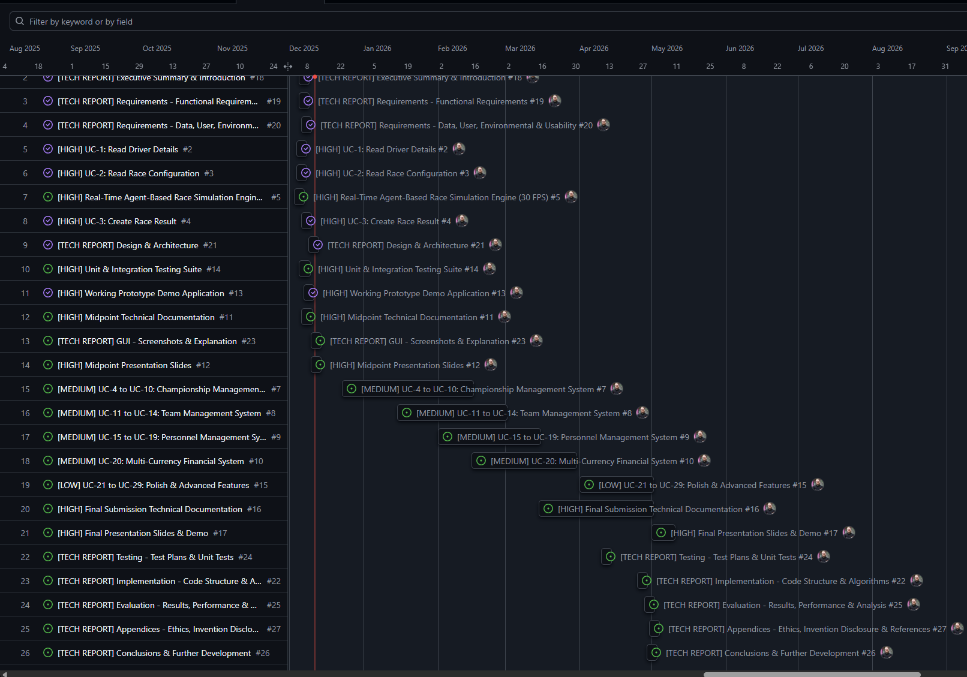

Testing

Testing Strategy
Testing for Momentum is structured across multiple levels to ensure system stability, performance, and fidelity of simulation outcomes. Unit, integration, system, and user testing are all incorporated to validate both functional and non-functional requirements. Each level of testing is designed to produce measurable results and inform iterative refinement cycles throughout development. Ethical considerations, including data privacy, informed consent, and participant anonymity, are integrated into all user evaluation procedures.

Unit Testing
Unit testing validates individual modules of the simulation. Driver progression, financial systems, race outcome calculations, and AI decision-making routines are tested against expected behaviours and edge cases. Probabilistic models for driver skill development, fatigue, and personality traits are verified for correct statistical distribution and consistency. Financial operations are checked for accuracy, ensuring budgets, sponsorships, and costs are correctly computed under stochastic conditions. Race outcome algorithms, including Monte Carlo simulations, are validated to maintain realistic variability while ensuring balance between drivers and teams.

Integration Testing
Integration testing ensures proper communication between the Python back-end, front-end, AI modules, and procedural content generation systems. JSON-based data exchanges are verified for accuracy and latency, and SQLite storage operations are tested for integrity across multi-season and multi-league scenarios. Metrics include data consistency, transaction success rates, and persistence reliability. Integration tests also verify that AI decisions, procedural generation outputs, and race telemetry are correctly reflected in the user interface, maintaining coherent emergent behaviours across the simulation.

System Testing
System-level testing evaluates Momentum under full operational conditions. Multi-league, multi-season simulations are run to assess emergent behaviour, computational performance, and scalability. Metrics include league variability, AI decision diversity, race outcome distribution, system load, and memory usage. Stress testing is performed to evaluate performance under high concurrency and extended simulation periods. Any bottlenecks in AI computation, procedural content generation, or database operations are identified and addressed to maintain real-time responsiveness and persistent state accuracy.

User Evaluation
User testing measures interface usability, engagement, and comprehension of the management systems. Participants interact with the full front-end, reviewing dashboards, race summaries, and team management tools. Quantitative metrics include task completion time, accuracy of actions, and interaction frequency. Qualitative metrics are gathered via structured surveys, focusing on perceived realism, clarity, and enjoyment. Ethical safeguards are enforced, including informed consent, voluntary participation, and secure handling of collected data. Feedback informs both interface improvements and algorithmic refinements to maintain realistic, emergent gameplay.
Overall, the testing framework ensures that Momentum achieves persistent, scalable, and believable motorsport simulation. Iterative results from unit, integration, system, and user testing directly guide algorithm adjustments, AI behaviour tuning, procedural content balancing, and front-end enhancements, guaranteeing a coherent, high-quality, and engaging management experience.

Reflective Journals

Supervision & Reflection Template
Student Name | Eoin Fitzsimons
Student Number | X23151374
Course | Computing
Supervisor
Month: September
What?
Came up with idea, a motorsport management simulator game, I found that all others in the sector are too shallow.
I have installed unity and activated the student plan.
I have downloaded notion to keep track of structure of the project.
I have decided to use a python backend with SQLite data storage and Unity front end
I use GitHub for version control
So What?
That alleviated the pressure of coming up and sifting through ideas, so that was a great success, but I am still at stage one essentially as I have nothing beyond an idea currently.
It’s a direction to go in, but a large hill to tackle.
It gave me a structure to write my notes into
I have a structure in mind
I have backups if I don’t like a change I made
Now What?
I need to come up with a proper name, a plan of attack, (which actually works as a name), and some basic branding that will improve the initial start in my opinion.
Need to figure out how to learn unity
Need to plan out my notes on the project structure.
Need to learn the languages
Plan branch paths and naming schemes
Student Signature

Supervision & Reflection Template
Student Name | Eoin Fitzsimons
Student Number | X23151374
Course | Computing
Supervisor | Emer Thornbury

Month: October
What?
I started building a Python prototype for my game. I began work on the team management, car development, financial management, and the race weekend structure and connected them through a basic Python GUI. The current version is only a prototype. None of the systems are fully finished, and the race simulation is not yet implemented. The main goal was to test ideas and system integration before moving to a more advanced platform.
So What?
The prototype allowed me to experiment with the game’s logic and data flow, and to identify key challenges early. While the Python GUI is functional enough for testing, it is not intended for the final product. My main success was establishing a working foundation for the game’s systems. The biggest challenge is that the project is still at an early stage, with many features incomplete or missing.
Now What?
Continue developing and refining the core systems in Python until the logic is solid.
Use the Python prototype as a reference and testing ground for gameplay mechanics.
Focus on implementing a real race simulation and improving system completeness before porting to Unity.
Student Signature | Eoin Fitzsimons

Supervision & Reflection Template
Student Name | Eoin
Student Number | X23151374
Course | Computing
Supervisor

Month: November
What?
Reflect on what has happened in your project this month?
took a break to work on other assignments
proposal, CRUD use cases, and feature priority
mostly planning stuff
So What?
Consider what that meant for your project progress. What were your successes? What challenges still remain?
Certainly helped give a direction with use cases and priorities, realised initial proposal was just plain stupid, overly ambitious, and unrealistic for a college project.
Now What?
What can you do to address outstanding challenges?
Get started on coding around use cases
Student Signature

Supervision & Reflection Template
Student Name | Eoin
Student Number | X23151374
Course | Computing
Supervisor

Month: December
What?
Reflect on what has happened in your project this month?
Built the real-time agent engine and connected it to the GUI.
Fixed a set of code warnings and cleaned up some function signatures.
Ran tests (quick checks and longer validation).
So What?
Consider what that meant for your project progress. What were your successes? What challenges still remain?
The project now simulates live racing cars move continuously, and agents make per-frame decisions attack/defend/manage
This change gives visible, behaviour for demos, but some docs still describe the old Monte Carlo approach.
also found balance issues too many DNFs in long races that need tuning.
Now What?
What can you do to address outstanding challenges?
Rewrite the technical report and proposal to describe the agent-based approach.
Tune incident parameters to reduce DNFs
Run GUI tests and import track data for the midpoint demo.
Student Signature

Other materials used
Any other reference material used in the project for example evaluation surveys etc.

